New Iodine-based Electrochemical Advanced Oxidation System for Water Disinfection: Are Disinfection By-products a Concern?

Chad Verwold¹, Alejandro Ortega-Hernandez¹, Jillian Murakami¹, Laura Patterson-Fortin², Jenny Boutros², Richard Smith², Susana Y. Kimura^{1,}*
¹University of Calgary, Department of Chemistry, 2500 University Dr. NW, Calgary, AB, T2N 1N4, Canada
²Biolargo Water Inc, Agrifood Discovery Place, Edmonton, AB T6H 2V8, Canada
* Corresponding author

Abstract

A novel electrochemical Advanced Oxidation System (AOS) has been recently developed for water disinfection where iodide is used to generate active iodine species in-situ. However, the presence of iodide during water disinfection can lead to the formation of iodinated disinfection byproducts (I-DBPs), which have been shown to be more cyto- and genotoxic than their chlorinated and brominated analogs. In this study, the formation of DBPs was assessed in ultrapure water, river water and secondary wastewater effluents treated by the AOS. A comprehensive total organic halogen and target DBP analysis was used that included 25 unregulated DBPs, and the total organic halogen (TOX) quantified as total organic chlorine (TOCl), total organic bromine (TOBr), and total organic iodine (TOI). Ultrapure water disinfection only quantified iodoform (TIM) at a maximum concentration of 0.90 ± 0.05 µg/L. River water results show that TOI increase from 1.3 ± 0.3 µg/L before disinfection (t=0) to a maximum of 3.5 ±1.1 µg/L. TIM and bromodiiodomethane (BDIM) were the only targeted iodo-trihalomethanes (I-THMs) that were quantified with a maximum total I-THM concentration of 0.44 µg/L. Secondary wastewater effluent disinfection results show that TOI increased from 1.8 ± 0.3 µg/L (t=0) to a maximum concentration of 35.3 ± 0.3 µg/L. Iodide and iodate were the main iodinated species exiting the AOS system with a iodine recovery of 94-101%. The results from this study show that the AOS formed low levels of iodinated DBPs in treated water sources that are comparable to the levels found in disinfected drinking water and wastewater.

Keywords
Disinfection by-products, advanced oxidation, electrochemical water treatment, total organic halogen, I-THMs, TOI
License: CC-BY-NC-ND; https://doi.org/10.1016/j.watres.2021.117340
- Introduction

Water disinfection has been used worldwide in drinking water and wastewater to inactivate pathogenic microorganisms that cause waterborne diseases such as cholera and typhoid. However, water disinfection unintentionally produces disinfection byproducts (DBPs) when chemical disinfectants react with natural organic matter, anthropogenic pollutants, and halide salts in source waters. Since DBPs were first discovered in 1974,(Rook, 1974) more than 700 DBPs have been identified in disinfected waters (Krasner et al., 2006a; Richardson, 2011; Richardson and Kimura, 2016; Richardson and Kimura, 2020; Richardson and Postigo, 2016; Richardson and Temes, 2018). However, only 12 DBPs are currently monitored by Canadian drinking water utilities (Health Canada, 2020). Four trihalomethanes (THMs) and five haloacetic acids make up the majority of regulated DBPs and are predominantly formed by chlorination, the most commonly used disinfectant (Crittenden, 2012). Alternative disinfectants (i.e., combined chlorine) can reduce the formation of regulated DBPs. However, the use of alternative disinfectants may promote the formation of other unregulated classes of DBPs including haloacetonitriles, haloacetamides, haloaldehydes, haloketones, halonitromethanes, nitrosamines, and iodinated-THMs (I-THMs) (Crittenden, 2012). Although these unregulated DBPs are found at lower concentrations, they have shown to be more cyto- and genotoxic than regulated-DBPs (Muellner et al., 2007; Plewa et al., 2008; Plewa et al., 2004; Richardson et al., 2008; Richardson and Plewa, 2020; Wagner and Plewa, 2017).

Although chlorine’s effectiveness as a disinfectant has many benefits, it also has several disadvantages including ineffectiveness against certain pathogens, (Driedger et al., 2000) and generation of potentially toxic DBPs. One alternative to chemical disinfection is electrochemical disinfection. The capability to treat wastewaters at ambient temperature and pressure, low solid waste production, and limited chemical addition while maintaining sufficient disinfection and decontamination makes electrochemical disinfection appealing (Feng et al., 2016). However, disadvantages include low treatment rates due to limited electrode surface area, high-energy consumption, high suspended solids, and the potential to generate DBPs.

In recent years, high surface area electrodes and electrochemical cells have been developed and optimized that address some disadvantages of electrochemical disinfection (Feng et al., 2016; Martínez-Huitle and Ferro, 2006). A new technology known as the Advanced Oxidation System (AOS) is a carbon-based packed-bed electrochemical water treatment system that uses a graphite-based electrode bed material, iodide as its principle electrochemically active input chemical, and a proprietary silica-based spacer to separate electrodes within the device (Code, 2020). The AOS generates in-situ active iodine species that serve as disinfectants at the anodic chamber (Code, 2020). Active iodine species are known to be effective oxidants against microbial pathogens (Gottardi, 1999). Iodine interferes with bacterial cellular function by oxidizing or iodinating proteins, nucleotides of DNA or RNA, or fatty acids, ultimately leading to cell death (Arnitz et al., 2015; Gottardi, 1999; Mcdonnell and Russell, 1999; Okochi et al., 2005). While molecular iodine (I₂) is generally thought to be the main iodine species responsible for bacterial inactivation, hypoiodious acid (HOI) and, periodate (IO₄⁻) are also known to exhibit bactericidal properties (Arnitz et al., 2015; Gottardi, 1999; Okochi et al., 2005). Recent results have shown that the AOS device exhibit high inactivation of bacteria Escherichia coli (6 log reduction) with low current density (0.6 mA/cm²) and a contact time of 5 minutes (Moustafa et al., 2021). Another recent study found that municipal wastewater spiked with benzo[a]pyrene or 17β-estradiol and treated by the AOS removed the observed biological effects of these organic pollutants on examined aquatic organisms (daphnia, zebrafish, and rainbow trout) (He et al., 2021). Additionally, treatment of wastewater effluents by the AOS reduced the bacterial load (10³ Colony Forming Unit (CFU)/ml in untreated wastewaters) to non-detect (He et al., 2021). The AOS contains cathodic cells that reduce electro-generated oxidizing compounds and eliminate the release of oxidants in treated waters (Code, 2020).

As with all chemical disinfectants, the active iodine species generated by the AOS could potentially form DBPs. Iodine-based oxidants have been shown to react with organic molecules and natural organic matter to form iodinated-DBPs (I-DBPs) (Bichsel and Von Gunten, 2000; Bougeard et al., 2010; Jones et al., 2012; Jones et al., 2011). Toxicological studies conducted in vitro have shown that I-DBPs are more toxic than brominated DBPs (Br-DBPs) and significantly more toxic than chlorine containing DBPs (Cl-DBPs) (Muellner et al., 2007; Wagner and Plewa, 2017). For example, within its chemical class, iodoform (LC50 of 6.6x10⁻⁵ M) has been found to be two orders of magnitude more cytotoxic than regulated bromoform (LC50 of 3.96 x 10⁻³ M) and chloroform (LC50 of 9.62 x 10⁻³ M) (Plewa and Wagner 2009; Wagner and Plewa, 2017). The higher toxicity of I-DBPs may pose a potential threat to public health (Richardson and Plewa, 2020).

The objective of this study was to holistically evaluate DBP formation in ultrapure, river and wastewater treated with the AOS. DBPs were comprehensively analyzed with total organic halogen and target DBP analysis. Total organic halogen is a hollistic approach that can quantify the total concentration of halogenated compounds by halogen type, that is, total organic chlorine (TOCl), total organic bromine (TOBr), and total organic iodine (TOI) (Hua and Reckhow, 2006; Kimura et al., 2017; Kristiana et al., 2015; Yang et al., 2014). The TOX analysis provides critical information because it can holistically quantify all the halogenated organic material that is often missed by target methods (Cuthbertson et al., 2019; Krasner et al., 2006b). Additionally, positive correlations have been found between TOX concentration and toxicity of disinfected waters (Ersan et al 2019; Kristiana et al, 2020). Also, TOI has been linked to higher toxicity in disinfected waters (Yang et al, 2014). Target methods based on gas chromatography (GC) tandem mass spectrometry (MS/MS) and (GC-MS) that included I-DBPs (dichloroiodomethane, chlorodiiodomethane, bromochloroiodomethane, dibromoiodomethane, bromodiiodomethane, iodoform, and iodoacetontirile) were also used in this study (Ortega-Hernandez et al., 2021). Further, this work studied the iodine speciation as a result of electrochemical disinfection by analyzing various iodine species in AOS treated waters. This study will help assess the formation of DBPs by AOS treatment of waters with varying levels of dissolved organic carbon. Results from this study will be used to improve the AOS design and scale-up and provide safe water by achieving high microbial inactivation and low formation of toxic DBPs.

2. Experimental Section
2.1 Reagents and Solutions
Potassium iodide (99.0%), sodium chloride (99.0%), sodium bromide (99.0%), sodium iodate (99.0%), sodium periodate (99.8%) and hydrogen peroxide (30%) were purchased from Sigma- Aldrich (Saint Louis, MO, USA). Nitric acid (Optima Grade), ammonium hydroxide (Optima Grade), and methyl tert-butylether (MTBE, Optima Grade) were purchased from Fisher Scientific (Waltham, MA, USA). Whatman borosilicate 0.45 μm glass filters were purchased from VWR (Radnor, PA, USA). Analytical standards for DBP analysis were bought from CanSyn Chem Corp. (Toronto, ON, Canada), Sigma-Aldrich (Saint Louis, MO, USA), Toronto Research Chemicals (Toronto, ON, Canada), and AccuStandard (New Haven, CT, USA). Specific details on purity can be found elsewhere (Ortega-Hernandez et al., 2021).

Analytical standards for bromide, iodide, and chloride were made by weighing halide salts on a Mettler XS104. Each standard was weighed directly in a metal-free sterile 50 mL centrifuge tubes (VWR, Radnor, PA, USA), filled with 20 μM ammonium hydroxide solution (absorbing solution), and weighed again to calculate the final concentration. Absorbing solution was prepared daily by adding 50 μL of hydrogen peroxide (30%) and 20 μL of ammonium hydroxide standard (0.5 M) and filled to the line with ultrapure water in a 500 mL volumetric flask. Analytical standards were covered in tinfoil and stored in the dark at 4° C. Iodate and periodate standards followed the same procedure, except they were made up of ultrapure water instead of absorbing solution. Analytical standards were found to be stable up to 4 months. A nitrate solution of 5,000 mg/L as NO₃⁻ (washing solution) was prepared by diluting concentrated nitric acid (5.3 mL) into 1L of ultrapure water and stored in a 1L fluorinated ethylene propylene bottle at 4°C in the dark. Ultrapure water (≥18.1 MΩ) was used to prepare all solutions in this study. The ultrapure water was obtained from DI water treated with a Barnstead B-Pure System followed by a Barnstead Micropure UV/UF System (Thermo Fisher Scientific, Waltham, MA, USA).

  - Advanced Oxidation System
Water samples were treated with the Advanced Oxidation System (AOS) that was patented (US 10,654,731 B2) and created by BioLargo Water (Edmonton, Canada). AOS operational parameter optimization was performed in a 6-chamber AOS reactor packed with graphite foam (Entegris) and a proprietary spacer. However, DBP formation potential of water samples was performed using a 12-chamber AOS reactor (Figure 1). The reactor was made of PVC with a height of 18 cm and an internal diameter of 4.5 cm. Platinum electrodes inserted into the anodes and cathodes were connected in parallel to the positive and negative outlets of a DC power supply (BK Precision), respectively. Untreated waters were pumped into the AOS by a Masterflex mechanical pump (Cole Parmer, Vernon Hills, IL, USA) entering through the bottom of the AOS and pushed upwards through a series of oxidation and reduction chambers (Figure 1).
The operational conditions of the AOS were optimized to achieve a 6-log inactivation of Escherichia coli. E. coli MC4100 was used in this study. Bacterial cultures were grown in Luria-Bertani (LB) medium at 37°C and aerated by shaking at 150 rpm. Overnight cultures were harvested and resuspended in RO water. RO water seeded ~10⁸ CFU/ml E. coli was passed through the AOS reactor at variable flow rates, KI concentrations at a total current density of 1.25 mA/cm² (total anodic active surfaces). Tested parameters were flow rate (40 and 80 mL/min), and KI concentration (2.5, 5, and 10 mg/L). Samples were collected at 5, 10, 15, 20, 30, 40, 50, and 60 minutes. The number of viable of E. coli cells after treatment were determined by spiral plating (Whitney Automatic Spiral Plater) of 50 µl aliquots on LB agar. Plates were incubated at 37°C for 18-20 hours. Before each experiment, the AOS was rinsed with KI for 30 minutes followed by ultrapure water for another 60 minutes. E. coli was not detected in the rinse cycle.
Prior to sample treatment, the AOS underwent a preconditioning step of 30 minutes with 10 mg/L KI in ultrapure water at 20 mA followed by a 30-minute ultrapure water rinse with no electricity applied. For this study, 6L of untreated waters were processed at a flow rate of 80 mL/min and a current of 20 mA across the AOS total current density 1.25 mA/cm² (total anodic active sites) and hydraulic residence time of 3.6 mins). Electricity was supplied by a DC power supply and the current was monitored by a handheld digital multimeter. Experiments were conducted for 60 min and sampled at 0, 1, 3, 5, 7, 15, 25, 35, 45, 55, and 60 minutes. The AOS performance was assessed using three different water matrices: ultrapure water, river water, and secondary wastewater effluent. Each water matrix was repeated in triplicate.

  - Sample Collection
River and municipal wastewater were collected in Calgary, AB, Canada. River water was collected from the Bow River approximately 4 kilometers downstream of a major wastewater treatment plant on February 6th, 2020. Secondary wastewater effluent prior to disinfection was collected on January 9th, 2020 as a 5-hour composite treated municipal wastewater that flows into Advancing Canadian Wastewater Assets (ACWA), a full-scale research plant located in Calgary, AB, Canada. The wastewater treatment process includes screen and grit removal, primary clarifier, activated sludge reactor, and secondary clarifier. Composite sample was obtained by collecting two bottles of 4 L of wastewater every hour for 5 hours and homogenized in two 20 L carboys. River and wastewater were filtered with a 0.45 μm membrane filters and stored in the dark at 4° C until they were treated with the AOS. Treated waters were collected in amber bottles (125 mL) with no headspace and stored in the dark at 4° C. Disinfected samples were analyzed for TOX and target DBPs within one week. Water quality parameters for collected samples are shown in Table 1.

  - Analytical Methods and Instrumentation
The TOX method was followed as outlined in Kimura et al (Kimura et al., 2017) with modifications using a Mitsubishi TOX system (Chigasaki, Japan) and a decoupled Dionex Integrion Ion Chromatograph (Thermo Fisher Scientific, Waltham, MA). Briefly, 50 mL of treated water were adsorbed by two activated carbon (AC) columns in series using the TXA-04 adsorption unit. A 15-mL washing solution of 5000 mg/L as NO₃⁻ was used to wash inorganic anions from the ACs. ACs were transferred to an ASC-240S solid autosampler that introduced the ACs into the AQF-2100H quick furnace. ACs were combusted with the following program: 500 s at the end position, 200 s at the cooling position, and 200 seconds at the home position at an argon and oxygen flow rate of 200 and 400 mL/min. Off-gases were collected using an AU-250 absorption carousel that held a centrifuge tube with 5 mL of 20 μM ammonium aqueous absorption solution. The absorption solution was analyzed with the ion chromatograph (IC) for chloride, bromide, and iodide. Seven calibration standards were used within the range of 5-500 μg/L with a coefficient of determination (R²)≥ 0.99. The IC was equipped with a Dionex IonPac AS20 microbore analytical column (2 x 250 mm), AG20 guard column, and a sample loop of 250 μL. The mobile phase was potassium hydroxide (KOH) introduced at a flow rate of 0.250 mL/min. The separation gradient was programmed starting at 5mM KOH for 10 min, followed by 35 mM KOH for 8 min, and a final 5 mM KOH for 12 min. IC chromatogram is shown in Figure S1 in Supplemental Information (SI). Temperatures for the column and detector were set 35°C and 30° C, respectively. Limits of detection are estimated to be 1 μg/L for TOCl, TOBr, and TOI based on IC lowest calibration point and sample concentration factor.

Iodate and periodate were also analyzed with the IC. Seven calibration standards were used within the range of 100-1500 μg/L with a R² value≥0.99. For this method, the IC was equipped with a Dionex Ionpac AS15 microbore analytical column (2 x 250 mm), AG15 guard column, and a sample loop of 250 μL. The mobile phase was KOH introduced at a flow rate of 0.300 mL/min. The separation gradient was programmed starting at 5 mM KOH for 12 minutes, followed by 25 mM KOH for 15 minutes, 50 mM KOH for 12 minutes, and a final 5 mM KOH for 7 minutes. Temperatures for the column and detector were set to 30 C°. IC chromatogram is shown in Figure S2 in SI. Triiodide was analyzed spectrophotometrically (λ=351 nm) using a Shimadzu UV-2700 UV spectrometer (Jung et al., 2014).

Target DBPs were quantified using two gas chromatography mass spectrometry (MS) methods. An Agilent 7890B GC with multi-mode inlet coupled to a 7000C Agilent tandem mass spectrometer (MS/MS) (Santa Clara, CA) was used to quantify 25 unregulated DBPs including 7 iodinated DBPs in ultrapure and river water samples (iodoacetonitrile, dichloroiodomethane, bromochloroiodomethane, dibromoiodomethane, chlorodiiodomethane, bromodiiodomethane, iodoform). Details of the analytical method are detailed elsewhere (Ortega-Hernandez et al., 2021). In brief, samples were extracted by liquid-liquid extraction with 3 x 3 mL of MTBE, dried over sodium sulfate, and concentrated to 200 μL under a low nitrogen flow. Method detection limits were between 2.0-68.9 ng/L. The second analytical method quantified 22 unregulated and regulated DBPs in wastewater samples using an Atomx XYZ (Teledyne Tekmar, Mason OH) purge and trap (P&T) system coupled to an HP 6890 GC coupled to a 5973 MS (Santa Clara, CA). This method also quantified 7 iodinated DBPs previously mentioned in the GC-MS/MS method in addition to 4 trihalomethanes (chloroform, bromoform, dichlorobromomethane, dibromochloromethane), 6 haloacetonitriles (trichloroacetonitrile, chloroacetonitrile, bromoacetonitrile, dichloroacetonitrile, bromochloroacetonitrile, dibromoacetonitrile), and 3 haloketones (1,1-dichloropropanone, 1,1,1-trichloropropanone, 1-bromo-1,1-dichloropropanone). The P&T system extracted DBPs from 25 mL of water sample using Helium gas and were trapped in a VOCARB 3000 Trap (Sigma-Aldrich, Saint Louis, MO, USA). Analytes were desorbed at 250 °C for 2 minutes and transferred directly to the GC-MS. Inlet temperature was held at 250°C under a constant flow of 1.0 mL/min in split mode (100:1). Analytes were separated using a J&W Agilent HP-5ms column (30 m, 0.25 mm, 0.25 µm). The oven’s initial temperature was 35°C and was ramped at 15 °C/min to 85°C followed by a second ramp at 30 °C/min to a final temperature of 280°C that was held for 2 min. Analytes were detected in SIM mode. Method detection limits were between 0.02-19.3 μg/L. All DBP analysis were quantified in triplicate.

Dissolved organic carbon was measured using a Shimadzu TOC-V (Kyoto, Japan) according to Standard Method 5310 B (Baird et al., 2017). Other water quality parameters were determined with a Hach (Loveland, CO, USA) 2100AN Turbidimeter, Shimadzu UV-2700, and Mettler Toledo Seven Compact pH meter.

- Results and Discussion
  - AOS Operational Conditions
The AOS operational conditions were optimized to achieve a 6-log inactivation of E. coli . The optimal current density, flow rate, and KI concentration were identified and shown in Figure 2. In Figure 2, with 2.5 mg/L KI, the lowest KI concentration tested, a 6 -log inactivation was observed after 15 minutes of run time. However, for 5 mg/L and 10 mg/L KI, E. coli counts decreased below the quantification limit (LoQ = 2.6) within 5 minutes of run time, representing an approximate 6-log reduction. Therefore, AOS treatment and DBP evaluation of water samples were conducted using the following conditions: 1.25 mA/cm² (total anodic active surfaces), 80 mL/min, and 5 ppm KI. The optimal current density required to achieve a 6-log reduction using the AOS is similar to published values for E. coli inactivation using other electrochemical cells (Ghasemian et al., 2017. Schmalz et al., 2009).

3.2. Ultrapure Water
Ultrapure water was treated by the AOS to evaluate the formation of DBPs in the absence of organic matter. TOX results are shown in Figure 3. TOCl and TOBr throughout the run were on average 10.4 ± 0.7 µg/L as Cl⁻ and 0.5 ± 0.1 µg/L as Br⁻, respectively. No measurable TOI was detected. Trace levels of TOCl could possibly be contributed from the ultrapure water system, the TOX sample process, potassium iodide that was added to ultrapure water, or the AOS apparatus. Controls with ultrapure water processed through the TOX analysis in triplicate had a TOCl concentration of 7.3 ± 2.7 µg/L. Therefore, the main contributor for TOCl seems to originate from the ultrapure water and TOX analysis. Controls did not detect TOBr. Overall, in the absence of organic matter a low formation of DBPs was expected. Target DBP analysis only quantified a small amount of iodoform (TIM) formation at 15 (0.78 ± 0.06 µg/L ) and 45 (0.90 ± 0.05 µg/L) minute samples. TIM was not detected prior to AOS treatment. It is possible that TIM might be produced from the reaction of active iodine species with graphite contained in the AOS system.

3.3. River Water Results
AOS treated river water was analyzed for TOCl, TOBr, TOI, and target DBPs. Results are plotted in Figures 4 and 5. TOI results in Figure 4 shows an initial concentration of 1.3 ± 0.3 µg/L as I⁻ followed by a slight increase during the first 35 minutes of AOS operation, with a maximum concentration of 3.5 ±1.1 µg/L as I⁻. TOI degradation was observed in the later half of AOS operation with a final concentration of 2.0 ± 1.0 µg/L as I⁻. Normalized TOI values by DOC concentration showed that a maximum of 0.41 µg/L as I⁻ per mg of DOC was formed. TOCl and TOBr appeared to be consistent throughout the run with an average concentration of 9.8 ± 1.2 µg/L as Cl⁻ and 1.8 ± 0.01 µg/L as Br⁻ respectively. These results suggest that TOCl and TOBr are not produced by the AOS system. For all three TOX measurements in Figure 4, a slow increase was observed for the first 5 minutes that could have been attributed to ultrapure water used in the AOS cleaning procedure. Ultrapure water appears to be exiting the system during the first few minutes of operation which may dilute the TOX measurements. Overall, TOX results showed a low TOI formation (1.3-3.5 µg/L as I⁻) despite processing river water with a relatively high DOC concentration of 8.5 mg/L. In a study by Pan et al, TOI was measured in chlorinated tap water across six major cities in China. TOI was quantified between 3.2 to 16.4 µg/L with a mean of 7.8 µg/L (Pan and Zhang, 2013).

I-THMs were the only target DBPs detected with a maximum total concentration of 0.44 ± 0.02 µg/L at 45 minutes of operation (Figure 5). Dichloroiodomethane (DCIM), bromochloroiodomethane (BCIM), bromodiiodomethane (BDIM), and iodoform (TIM) were all quantified in AOS processed samples where TIM represented 84% of the total I-THMs. However, only BDIM and TIM were not detected in controls (without AOS treatment). These results suggest that I-THMs with higher iodine substitution were preferentially formed in the AOS system, which has also been observed with other disinfectants in drinking water (Tugulea et al., 2018). Tugela et al. found that water treatment systems with higher levels of iodide (>10 µg/L) and higher iodide to bromide ratios primarily formed TIM. It was suggested that a higher iodide concentration might lead to higher concentration of active iodine species (i.e., hypoiodous acid) which can then react with the organic matter multiple times leading to a higher degree of iodination (Tugulea et al., 2018). Moustafa et al suggested that active iodine species within the AOS are generated and accumulated within the anodic regions of the device (Moustafa et al, 2021). It is hypothesized that a higher concentration of active iodine species within the anodic region may have led to multiple iodination reactions to preferentially form iodoform.

Although I-THMs quantified in this study were characterized in disinfected river and wastewater, most DBP literature have reported values primarily in drinking water and the following comparison is provided for context. I-THMs quantified in this study, were within range of I-THMs reported in drinking water (Richardson et al., 2008; Tugulea et al., 2018; Wei et al., 2013). In a nationwide Canadian study characterized six I-THMs across 64 drinking water utilities and revealed that I-THMs were detected in 46 out of 64 water treatment systems (Tugulea et al., 2018). Total I-THM concentration were quantified between 0.02 μg/L and 21.66 μg/L with a median concentration of 0.358 µg/L in the winter and 0.748 µg/L in the summer. Also, it was found that the highest I-THM levels occurred in utilities where their water sources had naturally occurring ammonia, as well as high bromide and iodide concentrations (Tugulea et al., 2018). It is well understood that chlorine can react with ammonia to produce chloramines which in turn may form hypoiodous acid (HOI) in iodide-containing waters (Bichsel and von Gunten, 1999). HOI can then react with organic matter to produce I-THMs (Bichsel and Von Gunten, 2000). This was also observed in a study by Smith et al, where DBP formation in natural waters treated with chlorine and iodine were compared (Smith et al., 2010). Richardson et al tested chlorinated and chloraminated drinking water from 22 cities in the United States and Canada for five iodo-acids and two iodo-trihalomethanes (Richardson et al., 2008). They found both iodo-trihalomethanes in all 22 plants, with maximum levels of 10.2 µg/L (mean of 1.34 µg/L) for BCIM and 7.9 µg/L for DCIM (mean of 1.59 µg/L). In China, Wei et al measured 9 regulated haloacetic acids, 4 regulated THMs, iodoacetic acid, and iodoform (TIM) in drinking waters from 13 water treatment plants in Shanghai (Wei et al., 2013). Their study revealed that TIM was present in all water treatment plants, with a maximum concentration of 1.25 µg/L and a median of 0.85 µg/L in the winter and 0.40 µg/L in the summer for the Huangpu River. I-THM concentrations found in drinking water utilities across Canada, the United States, and China have shown to be slightly higher than I-THMs produced by AOS disinfected river water.

3.4. Secondary Wastewater Effluent
DBP formation was also evaluated in AOS treated secondary wastewater effluents. TOX results plotted in Figure 6 show a TOI increase during AOS operation, reaching a maximum concentration of 35.3 ± 0.3 µg/L as I⁻ after 45 minutes, followed by a slight decrease towards the end of the run to 30.5 ± 3.0 µg/L as I⁻. A similar trend was observed in river water where TOI slightly decreased towards the end of the run. However, normalized TOI values by DOC concentration had a maximum of 1.18 µg/L as I⁻ per mg of DOC, which is 2.7x greater than river water. It is possible that the different composition found in effluent organic matter compared to natural organic matter may react more readily with active iodine species (Nam et al., 2008), despite both water samples having similar SUVA₂₅₄ (Weishaar et al., 2003). In a study by Pan et al, chlorinated secondary wastewater effluents in China produced a TOI mean value of 14.1 µg/L (Pan and Zhang, 2013), which was lower but within range than TOI generated from the AOS. Initial TOCl and TOBr values prior to AOS treatment (at t = 0) were 99.4 ± 3.9 µg/L as Cl⁻ and 5.2 ± 0.1 µg/L as Br⁻, respectively. TOCl and TOBr were 10.8 and 2.1 times higher in secondary wastewater effluents compared to river water possibly because wastewater may contain halogenated anthropogenic compounds that are not well removed from secondary treatment such as pesticides, brominated flame retardants, and pharmaceuticals (Barco-Bonilla et al., 2010; Chen et al., 2015; Chen et al., 2006; De Boer et al., 2003; Deng et al., 2015; Kim et al., 2013; Köck-Schulmeyer et al., 2013; Metcalfe et al., 2003). After AOS treatment, TOCl and TOBr remained consistent throughout the run with average values of 96.5 ± 1.4 µg/L as Cl⁻ and 4.7 ± 0.1 µg/L as Br⁻, respectively. These results show that the AOS treatment slightly reduces TOCl and TOBr that is initially present in wastewater effluents.

Target DBP detected in processed waters are shown in Figure 7 which include: 4 THMs, 3 I-THMs, and one HAN. However, the four THMs (dibromochloromethane, dichlorobromomethane, bromoform and chloroform), dichloroacetonitrile, and bromochloroiodomethane were already present in controls. The AOS system appears to form the higher substituted iodinated species, CDIM and TIM, due to high excess of iodide present (3.8 mg/L as I⁻). This agrees with the obtained results from the ultrapure water and river water experiments. The total I-THM concentration was less than 1 ± 0.087 µg/L where TIM had the largest contribution with 0.814 ± 0.079 µg/L. A recent study on chlorinated wastewater effluents (DOC = 7.38 mg/L) showed slightly lower total I-THM concentration between 0.151-0.168 µg/L (Ortega-Hernandez et al., 2021). However, secondary wastewater effluents processed by the AOS in this study, contained ~4x higher DOC concentration (29.7 mg/L). I-THMs levels were normalized to DOC concentration and was found that the AOS treated waters produced 0.033 µg I-THMs/mg DOC which is comparable to 0.023 µg I-THMs/mg DOC in chlorinated secondary effluents (Ortega-Hernandez et al., 2021).

3.5. Iodine Mass Balance
Untreated waters containing an initial iodide concentration could be converted to other iodine species after AOS treatment. Water was treated through a series of oxidation and reduction chambers where highly oxidized iodine species generated in the anodic chamber were intended to be reduced back to iodide at the final cathode (Moustafa et al, 2021). The following redox half-cell reactions show the possible iodine species that are relevant in the reactor (Dryhurst and Elving, 1967; Okochi et al., 2005; Shanmugam et al., 2014; Torimura et al., 1997; Moustafa et al, 2021).

$2I^{-}⇌I_{2}+2e^{-}$ (1)
$3I^{-}⇌{I_{3}}^{-}+2e^{-}$ (2)
$I^{-}+{3H}_{2}O⇌{{IO}_{3}}^{-}+{6H}^{+}+{6e}^{-}$ (3)
${{IO}_{3}}^{-}+{2OH}^{-}⇌{{IO}_{4}}^{-}+H_{2}O+{2e}^{-}$ (4)
$I^{-}+{OH}^{-}⇌HOI+ {2e}^{-}$ (5)

Based on reactions 1-5 iodide (I⁻), iodate (IO₃⁻), periodate (IO₄⁻), and triiodide (I₃⁻) were analyzed before and after disinfection at time = 0, 15, and 45 minutes. A mass balance was calculated from the measurement of I⁻, IO₃⁻, IO₄⁻ , I₃^{-,} and TOI before and after treatment. IO₃⁻ was not detected in any of the water samples prior to AOS treatment (t=0). IO₄⁻ and I₃⁻ (Figures S3 and S4) were not detected in any of the samples. HOI was indirectly measured with I₃⁻ according to equations 6 and 7. HOI can quickly react with excess I⁻ to form I₂ (with k = 4.4×10¹² M⁻² s⁻¹)(Eigen and Kustin, 1962; Pillar et al., 2013), I₂ and I⁻ will be in equilibrium with I₃⁻ (K= 740 M⁻¹)(Turner et al., 1972). Since I₃⁻ was not detected in samples, then HOI was also considered not to be present at significant levels. Mass balance results for ultrapure water, river water and secondary wastewater effluent are shown in Figure 8.

$HOI+ I^{-}+H^{+}\underset{→}{k}I_{2}+H_{2}O$ (6)
$I_{2}+ I^{-}⇌{I_{3}}^{-}$ (7)

Iodide mass balance on ultrapure water showed an average iodide recovery of 95.5 ± 2.0% at t=15 minutes and 94.2 ± 1.9% at t=45 minutes (Figure 8a). Iodide and iodate were the only iodine species detected in the ultrapure water samples. Iodate made up an average of 29.0 ± 1.5% of total iodine species at t=15 minutes and 30.5 ± 0.6% at t=45 minutes, while iodide made up the remaining portion. TOI was not detected before or after disinfection. The iodide (I⁻) levels used in the AOS system and quantified in this study do not exceed the EPA maximum tolerance level of 25 ppm of titratable iodine (U.S. E.P.A., 2018). Furthermore, iodate was found not to be genotoxic to mammalian cells, not mutagenic to bacterial Ames test, or the recessive lethal test in Drosophila melanogaster (Eckhardt et al, 1982; Poul et al, 2004). A full recovery of iodinated species was not observed possibly because iodinated species might have adsorbed onto the expanded graphite electrodes within the AOS. Previous studies have shown that iodide and iodate can adsorb onto activated carbon (Hoskins and Karanfil, 2002; Mahmudov and Huang, 2011).

Results for river water showed an average iodide mass balance recovery of 98.3 ± 2.7% at t=15 minutes and 101.1 ± 0.6% at t=45 minutes (Figure 8b). Iodide, iodate, and a trace levels of TOI were the only iodine species detected in treated river waters. Iodate made up an average of 24.0 ± 3.8% of total iodine species at t=15 and 24.6 ± 3.7% at t=45 minutes.

Treated secondary wastewater effluent revealed an average iodide mass balance recovery of 93.6 ± 9.5% at t=15 minutes and 95.1 ± 6.0% at t=45 minutes as shown in Figure 8c. Iodide, iodate, and a small amount of TOI were the only iodine species detected in the wastewater samples. Iodate made up an average of 11.6 ± 8.7% of total iodine species at t=15 minutes and 6.5 ± 0.9% at t=45 minutes. In one of the replicate trials at t=15 minutes, a significantly higher iodate concentration was quantitated compared to the other trials leading a slightly larger standard deviation. This could be due to faulty electrical connection at the final cathode in this trial, which would result in a larger portion of iodate not being reduced back to iodide in the treated waters. Overall, reduction of iodine species back to iodide was higher in secondary wastewater effluent, followed by river water and ultrapure water. Furthermore, the initial 5 ppm KI (~3.8 ppm as I⁻) spike only generated up to 0.1 % of iodinated DBPs quantified as TOI. Mainly, I⁻ and IO₃⁻ were the predominant species detected in the treated AOS effluent.

- Conclusions
The AOS is an new electrochemical water treatment system that generates active iodine species in-situ that can achieve a 6-log E.coli inactivation and reduce toxicity in aquatic organisms (He et al., 2021; Moustafa et al., 2021). However, active iodine species can also produce DBPs. AOS treatment forms I-DBPs at similar levels to chlorinated drinking waters and wastewater effluents. I-DBPs (in particular I-THMs) ranged between 0.3-1.9 µg/L across all the waters with TIM as the major I-DBP species possibly due to the high iodine to DOC ratio that may promote repeated iodination. From the three water matrices, wastewater produced the highest TOI (35.3 µg/L as I⁻) followed by river water (3.5 ±1.1 µg/L as I⁻). Higher DOC concentration might have resulted in a higher formation of I-DBP. This correlation was most evident in the TOI data. TOI was not detected in ultrapure water. Iodine mass balance shows that ≥90% of iodine species exist as iodide and iodate, with a very small portion (0.1%) contributing to I-DBP formation.

The results of this study show that the DOC concentration is directly related to the formation of I-DBPs by the AOS. Pre-treatment prior to the AOS could be considered for water sources with high organic content to minimize the DBP formation such as membrane filtration or ozone-biological active filtration. Furthermore, the study provided benchmark DBP levels of the operating conditions of the AOS (i.e., iodide concentration input, hydraulic residence time, and current density) that will be further optimized for the next iteration of the AOS scale-up design. Overall, this study suggests that the AOS provides a safe means of treating water while also identifying key considerations for system operations to minimize production of I-DBPs.

Conflicts of interest
The authors of this manuscript have no competing financial interests or personal relationships that could have influenced the outcomes of this study. This study received in-kind support and training from Biolargo Water.

Acknowledgements
This work would not be possible without the generous funding provided by The Natural Sciences and Engineering Research Council of Canada (NSERC) Engage grant 531274-2018 and Alberta Innovates Campus Alberta Small Business Engagement (CASBE) grant G2018000627. The authors would like to thank Dr. Ahmed Moustafa from BioLargo Water for training and communications throughout the project. Wastewater samples were obtained from Advancing Canadian Wastewater Assets (ACWA), a full-scale advanced wastewater treatment facility, with the help from Dr. Darina Kuzma, Dr. Andrea Scott, and Christine O’Grady. TOC results were provided by Farzin Malekani from the University of Calgary’s Environmental Science Program.

References

Arnitz, R., Nagl, M. and Gottardi, W. 2015. Comparison of the Microbicidal activity of monochloramine and iodine. Lett. Appl. Microbiol. 61, 518-522.
Baird, R., Bridgewater, L., American Public Health, A., American Water Works, A. and Water Environment, F. (2017) Standard methods for the examination of water and wastewater, Washington, D.C. : American Public Health Association.
Barco-Bonilla, N., Romero-González, R., Plaza-Bolaños, P., Garrido Frenich, A. and Martínez Vidal, J.L. 2010. Analysis and study of the distribution of polar and non-polar pesticides in wastewater effluents from modern and conventional treatments. J. Chromatogr. A 50, 7817-7825.
Bichsel, Y. and von Gunten, U. 1999. Oxidation of Iodide and Hypoiodous Acid in the Disinfection of Natural Waters. Environ. Sci. Technol. 33(22), 4040-4045.
Bichsel, Y. and Von Gunten, U. 2000. Formation of iodo-trihalomethanes during disinfection and oxidation of iodide-containing waters. Environ. Sci. Technol. 34(13), 2784-2791.
Bougeard, C.M.M., Goslan, E.H., Jefferson, B. and Parsons, S.A. 2010. Comparison of the disinfection by-product formation potential of treated waters exposed to chlorine and monochloramine. Water Res. 44(3), 729-740.
Chen, M., Cooper, V.I., Deng, J., Amatya, P.L., Ambrus, D., Dong, S., Stalker, N., Nadeau-Bonilla, C. and Patel, J. 2015. Occurrence of Pharmaceuticals in Calgary's Wastewater and Related Surface Water. Water Environ. Res. 87(5), 414-424.
Chen, M., Ohman, K., Metcalfe, C., Ikonomou, M.G., Amatya, P.L. and Wilson, J. 2006. Pharmaceuticals and endocrine disruptors in wastewater treatment effluents and in the water supply system of Calgary, Alberta, Canada. Water Qual. Res. J. of Canada 41(4), 351-364.
Code, K.R.S., Richard H.; Boutros, Jenny; Moustafa, Ahmed; Evans, Alexander; Pourrezaei, Parastoo; Hofstatter, Simon C. 2020 Method of treating contamination in a fluid stream with an electric current. Office, U.S.P.a.T. (ed), p. 20, United States.
Crittenden, J.C. (2012) MWH's water treatment principles and design, John Wiley & Sons, New Jersey.
Cuthbertson, A.A., Kimura, S.Y., Liberatore, H.K., Summers, R.S., Knappe, D.R.U., Stanford, B.D., Maness, J.C., Mulhern, R.E., Selbes, M. and Richardson, S.D. 2019. Does Granular Activated Carbon with Chlorination Produce Safer Drinking Water? From Disinfection Byproducts and Total Organic Halogen to Calculated Toxicity. Environ. Sci. Technol. 53(10), 5987-5999.
De Boer, J., Wester, P.G., Van Der Horst, A. and Leonards, P.E.G. 2003. Polybrominated diphenyl ethers in influents, suspended particulate matter, sediments, sewage treatment plant and effluents and biota from the Netherlands. Environ. Pollut. 122(1), 63-74.
Deng, D., Chen, H. and Tam, N.F.Y. 2015. Temporal and spatial contamination of polybrominated diphenyl ethers (PBDEs) in wastewater treatment plants in Hong Kong. Sci. Total Environ. 502, 133-142.
Driedger, A.M., Rennecker, J.L. and Mariñas, B.J. 2000. Sequential inactivation of Cryptosporidium parvum oocysts with ozone and free chlorine. Water Res. 34(14), 3591-3597.
Dryhurst, G. and Elving, P.J. 1967. Electrooxidation of halides at pyrolytic graphite electrode in aqueous and acetonitrile solutions. Anal. Chem. 39(6), 606-615.
Eckhardt, K., Gocke, E., King, M.-T., Wild, D. 1982. Mutagenic activity of chlorate, bromate, and iodate. Mutat. Res., 97:185.
Eigen, M. and Kustin, K. 1962. The Kinetics of Halogen Hydrolysis. J. Am. Chem. Soc. 84(8), 1355-1361.
Ersan, M.S., Liu, C., Amy, G., Plewa, M.J., Wagner, E.D. and Karanfil, T. 2019. Chloramination of iodide-containing waters: Formation of iodinated disinfection byproducts and toxicity correlation with total organic halides of treated waters. Sci. Total Environ. 697, 134142.
Feng, Y., Yang, L., Liu, J. and Logan, B.E. 2016. Electrochemical technologies for wastewater treatment and resource reclamation. Environ. Sci.-Wat. Res. 2(5), 800-831.
Ghasemian, B. Asadishad, S. Omanovic, and N. Tufenkji, 2017. Electrochemical disinfection of bacteria-laden water using antimony-doped tin-tungsten-oxide electrodes, Water
Res. 126, 299–307
Gottardi, W. 1999. Iodine and Disinfection: Theoretical Study on Mode of Action, Efficiency, Stability, and Analytical Aspects in the Aqueous System. Arch. Pharm. 332(5), 151-157.
He, Y., Patterson-Fortin, L., Boutros, J., Smith, R. and Goss, G.G. 2021. Removal of biological effects of organic pollutants in municipal wastewater by a novel advanced oxidation system. J. Environ. Manage. 280, 111855.
Health Canada 2020 Guidelines for Canadian Drinking Water Quality Summary Table, Water and Air Quality Bureau, Healthy Environments and Consumer Safety Branch, Health Canada, Ottawa, Ontario., Ottawa, Ontario.
Hoskins, J.S. and Karanfil, T. 2002. Removal and sequestration of iodide using silver-impregnated activated carbon. Environ. Sci. Technol. 36(4), 784-789.
Hua, G.H. and Reckhow, D.A. 2006. Determination of TOCl, TOBr and TOI in drinking water by pyrolysis and off-line ion chromatography. Anal. Bioanal. Chem. 384(2), 495-504.
Jones, D.B., Saglam, A., Song, H.C. and Karanfil, T. 2012. The impact of bromide/iodide concentration and ratio on iodinated trihalomethane formation and speciation. Water Res. 46(1), 11-20.
Jones, D.B., Saglam, A., Triger, A., Song, H. and Karanfil, T. 2011. I-THM Formation and Speciation: Preformed Monochloramine versus Prechlorination Followed by Ammonia Addition. Environ. Sci. Technol. 45(24), 10429-10437.
Jung, S.-H., Yeon, J.-W., Kang, Y. and Song, K. 2014. Determination of Triiodide Ion Concentration Using UV-Visible Spectrophotometry. Asian J. Chem. 26, 4084-4086.
Kim, M., Guerra, P., Theocharides, M., Barclay, K., Smyth, S.A. and Alaee, M. 2013. Parameters affecting the occurrence and removal of polybrominated diphenyl ethers in twenty Canadian wastewater treatment plants. Water Res. 47(7), 2213-2221.
Kimura, S.Y., Zheng, W., Hipp, T.N., Allen, J.M. and Richardson, S.D. 2017. Total organic halogen (TOX) in human urine: A halogen-specific method for human exposure studies. J. Environ. Sci. 58, 285-295.
Köck-Schulmeyer, M., Villagrasa, M., López de Alda, M., Céspedes-Sánchez, R., Ventura, F. and Barceló, D. 2013. Occurrence and behavior of pesticides in wastewater treatment plants and their environmental impact. Sci. Total Environ. 458-460, 466-476.
Krasner, S.W., Weinberg, H.S., Richardson, S.D., Pastor, S.J., Chinn, R., Sclimenti, M.J., Onstad, G.D. and Thruston, A.D. 2006a. Occurrence of a new generation of disinfection byproducts. Environ. Sci. Technol. 40(23), 7175-7185.
Krasner, S.W., Weinberg, H.S., Richardson, S.D., Pastor, S.J., Chinn, R., Sclimenti, M.J., Onstad, G.D. and Thruston Jr, A.D. 2006b. Occurrence of a New Generation of Disinfection Byproducts. Environ. Sci. Technol. 40(23), 7175-7185.
Kristiana, I., McDonald, S., Tan, J., Joll, C. and Heitz, A. 2015. Analysis of halogen-specific TOX revisited: Method improvement and application. Talanta 139, 104-110.
Kristiana, I., McDonald, S. and Joll, C.A. 2020. The forest or the trees: a critical review on the analysis of total organic halogen (TOX) in drinking waters and its utility as a water quality parameter. Environ. Sci.-Wat. Res. 6(9), 2313-2330.
Mahmudov, R. and Huang, C.P. 2011. Selective adsorption of oxyanions on activated carbon exemplified by Filtrasorb 400 (F400). Sep. Purif. Technol. 77(3), 294-300.
Martínez-Huitle, C.A. and Ferro, S. 2006. Electrochemical oxidation of organic pollutants for the wastewater treatment: Direct and indirect processes. Chem. Soc. Rev. 35, 1324-1340.
Mcdonnell, G. and Russell, A.D. 1999. Antiseptics and disinfectants: Activity, action, and resistance. Clin. Microbiol. Rev. 12(1), 147-179.
Metcalfe, C.D., Koenig, B.G., Bennie, D.T., Servos, M., Ternes, T.A. and Hirsch, R. 2003. Occurrence of neutral and acidic drugs in the effluents of canadian sewage treatment plants. Environ. Toxicol. Chem. 22(12), 2872-2880.
Moustafa, A., Evans, A., Hofstetter, S., Boutros, J., Pourrezaei, P., Zhang, C., Patterson-Fortin, L., Laing, C., Goertzen, C., Smith, R., Code, K.R., Cheng, N., Blanchard, P.E.R., Bettman, N., Alam, R., McPhedran, K., Fallah, Z., Roberts, E. and Gaultois, M. 2021. Operando Studies of Iodine Species in an Advanced Oxidative Water Treatment Reactor https://doi.org/10.26434/chemrxiv.13611347.v1
Muellner, M.G., Wagner, E.D., McCalla, K., Richardson, S.D., Woo, Y.-T. and Plewa, M.J. 2007. Haloacetonitriles vs regulated haloacetic acids are nitrogen-containing DBPs more toxic. Environ. Sci. Technol. 41, 645-651.
Nam, S.-N., Krasner, S.W. and Amy, G.L. (2008) Advanced Environmental Monitoring. Kim, Y.J. and Platt, U. (eds), pp. 259-270, Springer Netherlands, Dordrecht.
Okochi, M., Yokokawa, H., Lim, T.-K., Taguchi, T., Takahashi, H., Yokouchi, H., Kaiho, T., Sakuma, A. and Matsunaga, T. 2005. Disinfection of Microorganisms by Use of Electrochemically Regenerated Periodate. Appl. Environ. Microb. 71(10), 6410-6413.
Ortega-Hernandez, A., Acayaba, R., Verwold, C., Montagner, C.C. and Kimura, S.Y. 2021. Emerging investigator series: emerging disinfection by-product quantification method for wastewater reuse: trace level assessment using tandem mass spectrometry. Environ. Sci.-Wat. Res. 7(2), 285-297.
Pan, Y. and Zhang, X. 2013. Total organic iodine measurement: A new approach with UPLC/ESI-MS for off-line iodide separation/detection. Water Res. 47(1), 163-172.
Pillar, E.A., Guzman, M.I. and Rodriguez, J.M. 2013. Conversion of Iodide to Hypoiodous Acid and Iodine in Aqueous Microdroplets Exposed to Ozone. Environ. Sci. Technol. 47(19), 10971-10979.
Plewa, M.J. and Wagner, E.D., 2009. “Mammalian Cell Cytotoxicity and Genotoxicity of Disinfection by-Products), Water Research Foundation, Denver, CO.
Plewa, M.J., Muellner, M.G., Richardson, S.D., Fasano, F., Buettner, K.M., Woo, Y.T., Mckague, A.B. and Wagner, E.D. 2008. Occurrence, synthesis, and mammalian cell cytotoxicity and genotoxicity of haloacetamides: An emerging class of nitrogenous drinking water disinfection byproducts. Environ. Sci. Technol. 42(3), 955-961.
Plewa, M.J., Wagner, E.D., Richardson, S.D., Thruston, A.D., Woo, Y.-T. and McKague, A.B. 2004. Chemical and biological characterization of newly discovered iodoacid drinking water disinfection by-products. Environ. Sci. Technol. 38(18), 4713-4722.
Poul, J.M., Huet, S., Godard, T., Sanders, P., 2004. Lack of genotoxicity of potassium iodate in the alkaline comet assay and in the cytokinesis-block micronucleus test. Comparison to potassium bromate, Food Chem. Toxicol. 42, 203–209.
Richardson, S.D. (2011) The Encyclopedia of Environmental Health. Nriagu, J.O. (ed), pp. 110-136, Elsevier: Burlington.
Richardson, S.D., Fasano, F., Ellington, J.J., Crumley, F.G., Buettner, K.M., Evans, J.J., Blount, B.C., Silva, L.K., Waite, T.J., Luther, G.W., Mckague, A.B., Miltner, R.J., Wagner, E.D. and Plewa, M.J. 2008. Occurrence and mammalian cell toxicity of iodinated disinfection byproducts in drinking water. Environ. Sci. Technol. 42(22), 8330-8338.
Richardson, S.D. and Kimura, S.Y. 2016. Water Analysis: Emerging Contaminants and Current Issues. Anal. Chem. 88(1), 546-582.
Richardson, S.D. and Kimura, S.Y. 2020. Water Analysis: Emerging Contaminants and Current Issues. Anal. Chem. 92(1), 473-505.
Richardson, S.D. and Plewa, M.J. 2020. To regulate or not to regulate? What to do with more toxic disinfection by-products? J. Environ. Chem. Eng. 8(4), 103939.
Richardson, S.D. and Postigo, C. (2016) Comprehensive Analytical Chemistry. Pérez, S., Eichhorn, P. and Barceló, D. (eds), pp. 335-356, Elsevier.
Richardson, S.D. and Temes, T.A. 2018. Water Analysis: Emerging Contaminants and Current Issues. Anal. Chem. 90(1), 398-428.
Rook, J.J. 1974. Formation of Haloforms during Chlorination of Natural Waters. Water Treatment and Examination 23, 234-243.
Shanmugam, R., Sathiyanarayanan, K. and Kumar, A.S. 2014. A Simple Colorimetric Screening of Nitrite Using Iodide in an Acidic pH Solution. Austin J. Anal. Pharm. Chem. 1(6).
Schmalz, V., Dittmar, T., Haaken, D., and Worch, E., 2009. Electrochemical disinfection of biologically treated wastewater from small treatment systems by using boron-doped diamond (BDD) electrodes - Contribution for direct reuse of domestic wastewater, Water Res. 43, 5260–5266.
Smith, E.M., Plewa, M.J., Lindell, C.L., Richardson, S.D. and Mitch, W.A. 2010. Comparison of Byproduct Formation in Waters Treated with Chlorine and Iodine: Relevance to Point-of-Use Treatment. Environ. Sci. Technol. 44(22), 8446-8452.
Torimura, M., Kano, K., Ikeda, T., Goto, M. and Ueda, T. 1997. On-line electrochemical detection of carbohydrates coupled with the periodate oxidation. J. Chromatogr. A 790(1-2), 1-8.
Tugulea, A.-M., Aranda-Rodriguez, R., Bérubé, D., Giddings, M., Lemieux, F., Hnatiw, J., Dabeka, L. and Breton, F. 2018. The influence of precursors and treatment process on the formation of Iodo-THMs in Canadian drinking water. Water Res. 130, 215-223.
Turner, D.H., Flynn, G.W., Sutin, N. and Beitz, J.V. 1972. Laser Raman temperature-jump study of the kinetics of the triiodide equilibrium. Relaxation times in the 10-8 -10-7 second range. J. Am. Chem. Soc. 94(5), 1554-1559.
U.S. E.P.A., Reregistration Eligibility Decision For Iodine and Iodophor Complexes, 2006, 739-R-06-010.
Wagner, E.D. and Plewa, M.J. 2017. CHO cell cytotoxicity and genotoxicity analyses of disinfection by-products: An updated review. J. Environ. Sci. 58, 64-76.
Wei, X., Chen, X., Wang, X., Zheng, W., Zhang, D., Tian, D., Jiang, S., Ong, C.N., He, G. and Qu, W. 2013. Occurrence of Regulated and Emerging Iodinated DBPs in the Shanghai Drinking Water. PLoS ONE 8(3).
Weishaar, J.L., Aiken, G.R., Bergamaschi, B.A., Fram, M.S., Fujii, R. and Mopper, K. 2003. Evaluation of Specific Ultraviolet Absorbance as an Indicator of the Chemical Composition and Reactivity of Dissolved Organic Carbon. Environ. Sci. Technol. 37(20), 4702-4708.
Yang, Y., Komaki, Y., Kimura, S.Y., Hu, H.-Y., Wagner, E.D., Mariñas, B.J. and Plewa, M.J. 2014. Toxic Impact of Bromide and Iodide on Drinking Water Disinfected with Chlorine or Chloramines. Environ. Sci. Technol. 48(20), 12362-12369.

Tables and Figures

Table 1. Sample water quality parameters

 | River Water | Wastewater
Location | Bow River | ACWA
Date | February 6, 2020 | January 9, 2020
pH | 7.41 | 7.51
Chloride (mg/L) | 26.1 | 140.7
Bromide (mg/L) | 0.4 | 1.7
Iodide (µg/L) | N.D. | N.D.
DOC (mg/L) | 8.5 | 29.7
SUVA ₂₅₄ (L/mg-m) | 0.435 | 0.454
Turbidity (NTU) | 0.384 | 0.695

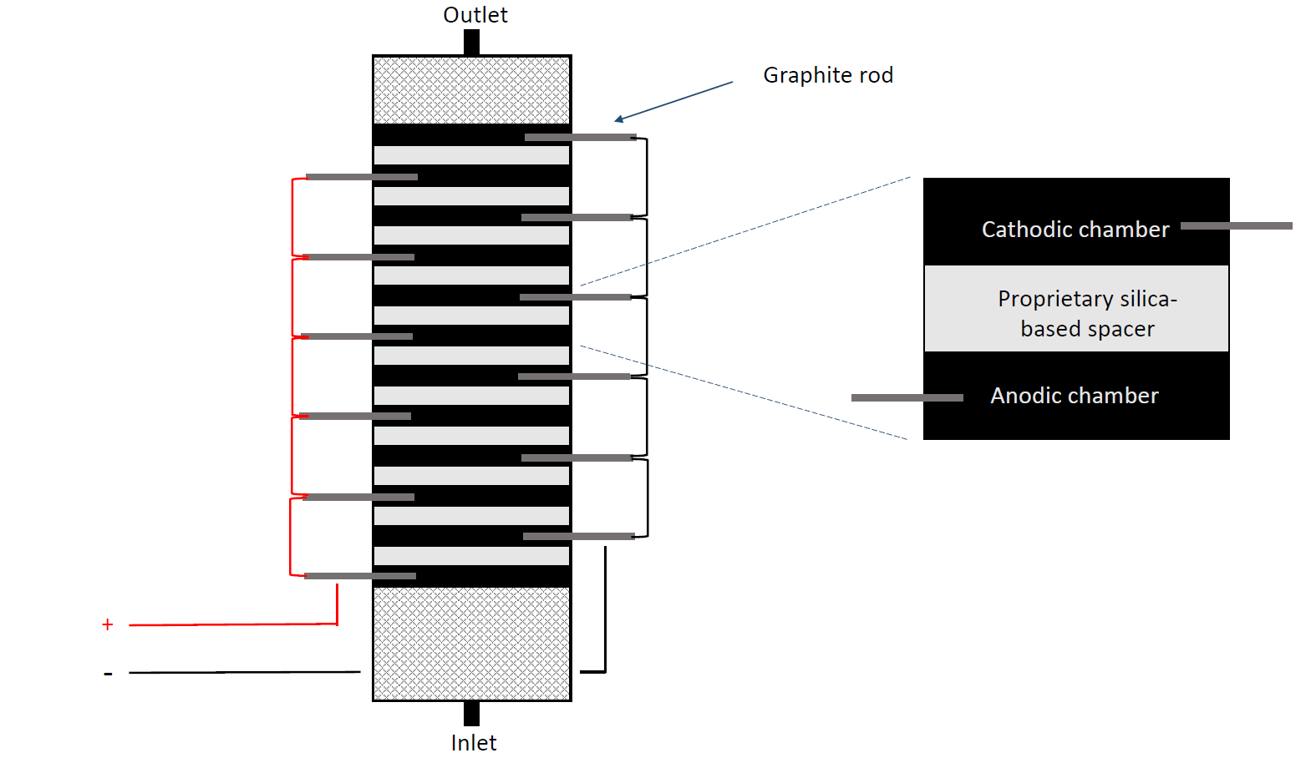
Figure 1. Schematic of the Advanced Oxidation System (AOS).

Figure 2. AOS Escherichia coli inactivation with increasing KI concentration, flow=80 mL/min, current density = 1.25 mA /cm² (total active anodic surfaces) (Average of 3-5 replicates). Limit of quantification for plating method is log (cfu/mL)= 2.6.
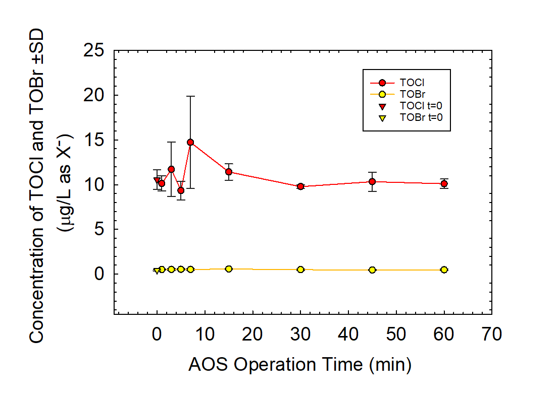

Figure 3. TOCl and TOBr data as the result of ultrapure water disinfection by AOS. TOI was not detected. Each data point is the average and standard deviation of three replicates. Ultrapure water prior to treatment is shown at t=0.
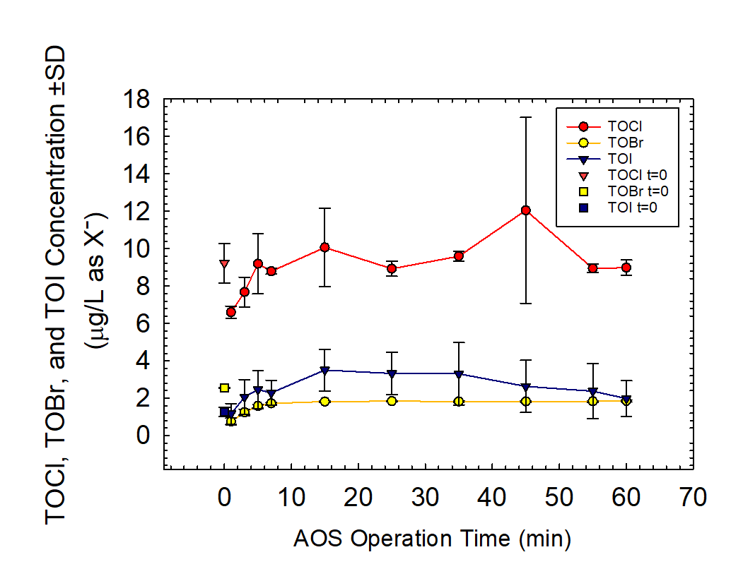
Figure 4. TOCl, TOBr, and TOI data as the result of river water disinfection by AOS. Each data point is the average and standard deviation of three replicates. River water prior to AOS treatment is shown at t=0.

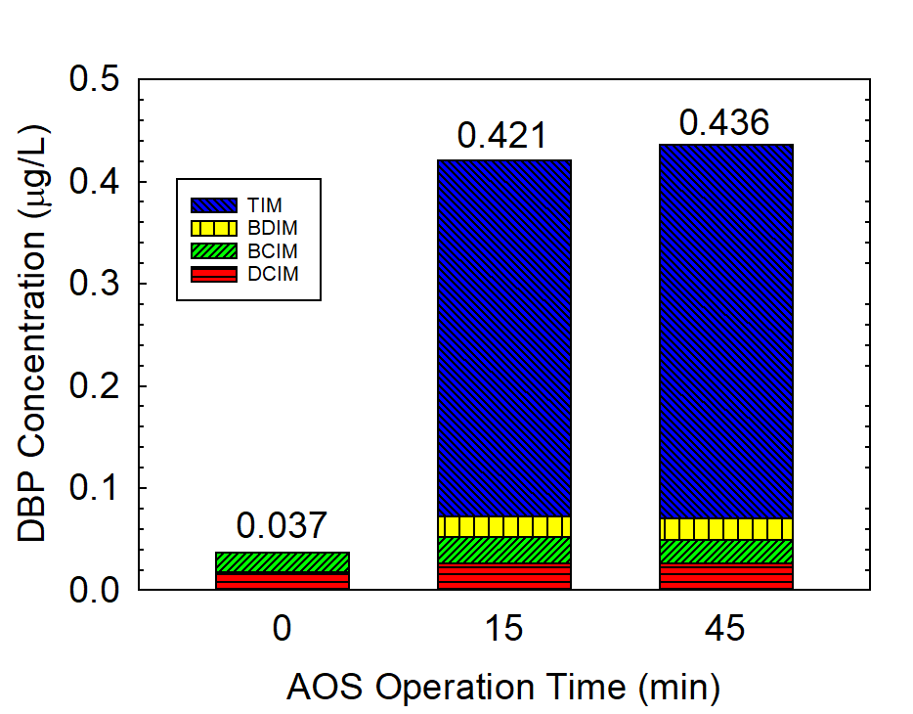
Figure 5. Target DBPs quantified in river water samples at t = 0, 15, 45 minutes. Each DBP measurement is the average of three replicates.

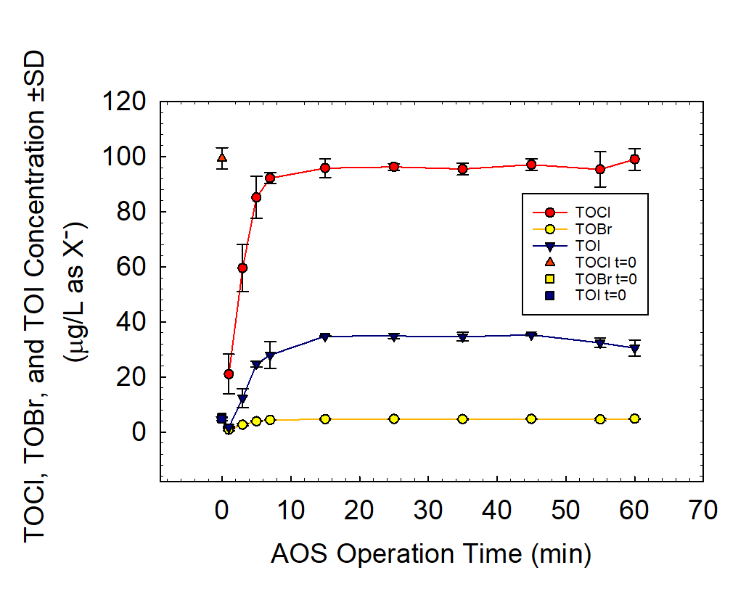
Figure 6. TOCl, TOBr, and TOI data as the result of secondary wastewater effluent disinfection by AOS. Each data point is the average and standard deviation of three replicates. Secondary wastewater effluent to AOS treatment is shown at T=0.

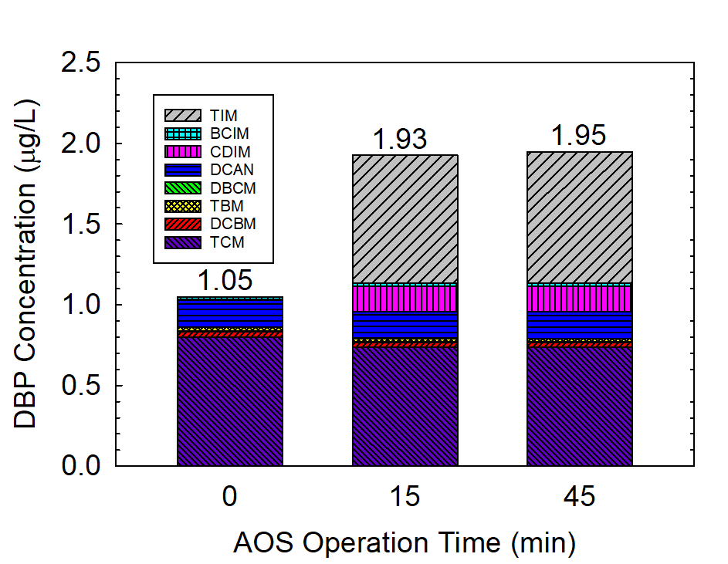
Figure 7. Target DBPs quantified in secondary wastewater effluent samples at t = 0, 15, 45 minutes. Each DBP measurement is the average of three replicates.

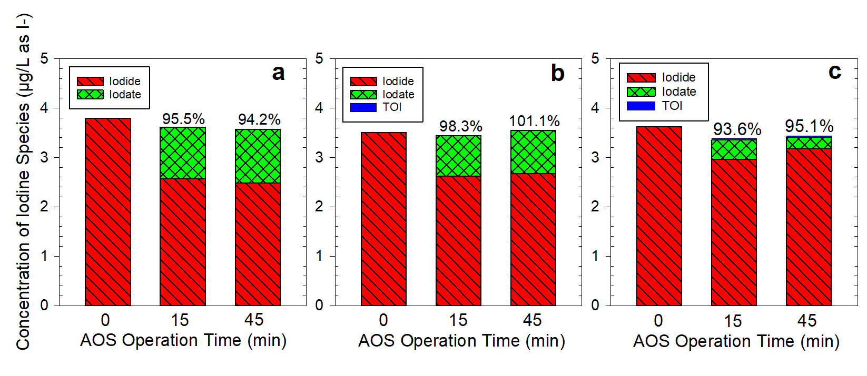
Figure 8. Mass balance of iodine species before (t=0) and after disinfection (t= 15 and 45 minutes) in a) ultrapure water, b) river water, and c) secondary wastewater effluent. Concentration of iodine species is the mean of three replicates. TOI was not detected in ultrapure water.

