Formation Potential and Analysis of 32 Regulated and Unregulated Disinfection By-Products: Two New Simplified Methods

Jillian N. Murakami ^{∆,1}, Xu Zhang^{∆,2}, Joanne Ye², Amy M. MacDonald², Jorge Pérez Pérez¹, David W. Kinniburgh², Susana Y. Kimura¹*
¹Department of Chemistry, University of Calgary,Calgary, Alberta, T2N 1N4, Canada
²Alberta Centre for Toxicology, University of Calgary, Calgary, Alberta, T2N 4N1,Canada

Submitted for publication as an Original Research Paper in:
Journal of Environmental Sciences

∆ First co-authors
*Corresponding Author
Phone: (403) 220-7519
Fax: (403) 289-9488
E-mail: s.kimurahara@ucalgary.ca

License: CC-BY-NC-ND; https://doi.org/10.1016/j.jes.2022.04.037

ABSTRACT
Water disinfection is an essential process that provides safe water by inactivating pathogens that cause waterborne diseases. However, disinfectants react with organic matter naturally present in water, leading to the formation of disinfection by-products (DBPs). Multi-analyte methods based on mass spectrometry (MS) are preferred to quantify multiple DBP classes at once however, most require extensive sample pre-treatment and significant resources. In this study, two analytical methods were developed for the quantification of 32 regulated and unregulated DBPs. A purge and trap (P&T) coupled with gas chromatography mass spectrometry (GC-MS) method was optimized that automated sample pre-treatment and analyzed volatile and semi-volatile compounds, including trihalomethanes (THMs), iodinated trihalomethanes (I-THMs), haloacetonitriles (HANs), haloketones (HKTs) and halonitromethanes (HNMs). LOQs were between 0.02-0.4 µg/L for most DBPs except for 8 analytes that were in the low µg/L range. A second method with liquid chromatography (LC) tandem mass spectrometry (MS/MS) was developed for the quantification of 10 haloacetic acids (HAAs) with a simple clean-up and direct injection. The LC-MS/MS direct injection method has the lowest detection limits reported (0.2-0.5 µg/L). Both methods have a simple sample pre-treatment, which make it possible for routine analysis. Hyperchlorination and uniform formation conditions (UFC) formation potential tests with chlorine were evaluated with water samples containing high and low TOC. Hyperchlorination formation potential test maximized THMs and HAAs while UFC maximized HANs. Ascorbic acid was found to be an appropriate quencher for both analytical methods. Disinfected drinking water from four water utilities in Alberta, Canada were also evaluated.

Keywords: disinfection byproducts, purge and trap, LC-MS/MS, drinking water, DBP formation potential, HAAs, HANs
- INTRODUCTION
Water disinfection is used in water treatment to inactivate pathogens that cause waterborne diseases. However, disinfectants can also unintentionally react with constituents that are already present in source waters, such as natural organic matter and halide ions, to produce disinfection byproducts (DBPs). More than 700 DBPs with a high chemical diversity have been identified in disinfected waters (Krasner et al., 2006a; Richardson, 2011; Richardson and Kimura, 2016; Richardson and Kimura, 2020; Richardson and Postigo, 2016; Richardson and Ternes, 2018, 2022). Haloacetonitriles (HANs), trihalomethanes (THMs), halonitromethanes (HNMs), haloketones (HKTs), haloaldehydes (HALs), iodo-trihalomethanes (I-THMs), and haloacetic acids (HAAs) are a few DBP chemical classes that are most widely studied.
Chemical and physical properties of DBPs are varied and most analytical methods analyze specific DBP class(es) with similar properties (Richardson and Kimura, 2016; Richardson and Kimura, 2020; Richardson and Ternes, 2011, 2014, 2018). However, to conduct comprehensive studies that can target multiple DBP classes at once, multi-analyte methods based on mass spectrometry (MS) are preferred more recently (Bougeard et al., 2010; Carter et al., 2019; Cuthbertson et al., 2020; Kimura et al., 2019; Krasner et al., 2006b; Ortega-Hernandez et al., 2021; Weinberg et al., 2002). Gas chromatography (GC) is the main separation technique used, but electrospray ionization (ESI) coupled with liquid chromatography (LC) could be applied for thermally labile and large polar DBPs not detectable by GC-MS (Wawryk et al., 2021). Additionally, sample pre-treatment is required for DBP quantification, which may include liquid–liquid extraction (LLE) (Bougeard et al., 2010; Carter et al., 2019; Cuthbertson et al., 2020; Kimura et al., 2019; Krasner et al., 2006b; Ortega-Hernandez et al., 2021; Weinberg et al., 2002), solid phase microextraction (SPME) (Allard et al., 2012; Kermani et al., 2013; Kristiana et al., 2012; Luo et al., 2014), purge and trap (P&T) (Nikolaou et al., 2002; Pérez Pavón et al., 2008; USEPA, 1995a), and solid phase extraction (SPE) (Chu et al., 2016; Kinani et al., 2018; Roumiguières et al., 2018; Zhou et al., 2020). P&T coupled with GC-MS has the advantage that the extraction and analysis are automated by the instrument, which frees up human resources and is ideal for routine analysis. This is particularly helpful for laboratories that need to process multiple samples per day. However, most P&T methods are applied solely for the analysis of THMs and other volatile organic compounds.
GC equipped with electron capture detection (ECD) (USEPA, 1995c) or MS (Postigo et al., 2018; Xie, 2001) is commonly used to analyze HAAs. However, due to the strongly polar and acidic character (pKa range 0.7–3.1) of HAAs (Scifinder), these compounds require derivatization to form their corresponding methyl esters (haloacetic acid methyl ester, HAAME), which are more volatile than the original HAAs, prior to GC based analysis. To avoid this step, ion chromatography (IC) or LC coupled to electrospray ionization (ESI) mass spectrometry methods, including tandem mass spectrometry (MS/MS) and high resolution MS (HRMS), have been developed for the analysis of HAAs with pre-sample clean-up (Chen et al., 2009; Cheng et al., 2021; Lee et al., 2018; USEPA, 2009; Wu et al., 2017) or by direct injection of aqueous samples (Planas et al., 2019; Postigo et al., 2020). IC–MS/MS has been successfully used for the quantitative analysis of up to 13 HAAs and 2,2-dichloropropionic acid in water without pre-sample treatment. Sub μg/L levels of analytes (<0.41 µg/L) were achieved. However, the potential MS interferences of other anions commonly present in water matrices, and the complexity of the technique posed problems with the use of this technique, in addition to the high cost. Therefore, the use of LC-MS/MS to determine HAAs in water has gained popularity in recent years. Direct injection LC-MS/MS has been favored recently due to its high throughput without pre-sample clean-up. In general, direct injection LC-MS/MS methods provide comparable sensitivity and accuracy to those obtained with SPE and LLE preconcentration methods. A limit of quantification (LOQ) for most HAAs of between 0.6 and 6 µg/L was achieved for tap water and surface water. However, sensitivity concerns in direct injection methods were reported for monochloroacetic acid (MCAA) and trihalogenated HAA because of the matrix effect of the samples (Planas et al., 2019; Postigo et al., 2020). The linear range of internal standard (IS)-based calibration curves usually can expand the LOQ of the HAA to 100 µg/L.
As more studies evaluate multiple classes of DBPs it is important to also evaluate the DBP formation potential tests that maximizes unregulated DBPs. Multiple factors affect DBP formation during disinfection, such as the type of organic matter (i.e. effluent, lake), disinfectant, contact time, pH, and temperature. For that reason, DBP formation potential tests known as uniform formation conditions (UFC) (24 h contact time) and hyperchlorination (7-day contact time) are used to evaluate DBP formation potential (under the same experimental conditions) that allow a direct comparison across different water samples. However, these methods were designed to maximize the formation of THMs and HAAs and not unregulated DBPs.
The objectives of this study were to 1) develop and validate two analytical methods that can quantify 32 regulated and unregulated DBPs for routine analysis which requires short analysis time and/or automation, and 2) evaluate DBP formation potential conditions that maximizes the formation of unregulated DBPs for local Alberta waters. To achieve this, a P&T GC-MS method was developed that quantifies volatile and semi-volatile compounds including THMs, I-THMs, HANs, HKTs and HNMs. A second method with LC-MS/MS was developed that quantifies 10 HAAs (including iodoacetic acid) with a simple clean-up. Both methods were used to evaluate disinfected waters in Alberta and evaluate DBP formation potential from waters that contained high and low organic carbon.

- EXPERIMENTAL
  - Chemicals and Reagents
Ultrapure water used for standards and calibrations was distilled, deionized and ultrapurified by a Barnstead B-Pure system followed by a Barnstead MicroPure UV/UF system to obtain a resistance ≥18.2 MΩ cm and a total organic carbon concentration of <5 µg/L (referred to herein as ultrapure water).
A certified reference material THM mix (2000 ppm each in methanol) containing tricholoromethane (TCM), dichlorobromomethane (DCBM), dibromochloromethane (DBCM) and tribromomethane (TBM) was purchased from Sigma-Aldrich (Oakville, ON, Canada). Individual standards for chloroacetonitrile (CAN), bromoacetonitrile (BAN), iodoacetonitrile (IAN) and triiodomethane (TIM) were purchased from Sigma-Aldrich, while those for dichloronitromethane (DCNM), dichloroiodomethane (DCIM), bromochloroiodomethane (BCIM), dibromoiodomethane (DBIM), chlorodiiodomethane (CDIM) and bromodiiodomethane (BDIM) were from CanSyn Chem. Corp. (Toronto, ON, Canada). 1-Bromo-1,1-dichloropropane (1B11DCP) was purchased from Toronto Research Chemicals (North York, ON, Canada). Trichloroacetonitrile (TCAN), dichloroacetonitrile (DCAN), bromochloroacetonitrile (BCAN), dibromoacetonitrile (DBAN), 1,1-dichloropropane (11DCP), 1,1,1-trichloropropane (111TCP) and trichloronitromethane (TCNM) were from AccuStandard (New Haven, CT, USA). Individual stock standard solutions were prepared in 99.9% extra dry acetonitrile from Fisher Scientific (Fair Lawn, NJ, USA), followed by sub-stock mixes containing all compounds from each DBP class, also in extra dry acetonitrile. Analytical standard of iodoacetic acid (IAA) and a certified reference material HAA mix (2000 ppm each in MTBE) containing monochloroacetic acid (MCAA), dichloroacetic acid (DCAA), bromochloroacetic acid (BCAA), monobromoacetic acid (MBAA), dibromoacetic acid (DBAA), trichloroacetic acid (TCAA), bromodichloroacetic acid (BDCAA), chlorodibromoacetic acid (CDBAA) and tribromoacetic acid (TBAA) were purchased from Sigma-Aldrich (Oakville, ON, Canada). HAA working standards were prepared by mixing the HAA mix and IAA standard in methyl tert-butyl ether (MTBE). Individual deuterated internal standards (MCAA-d3, DCAA-d2 and DBAA-d3) were purchased from CDN isotopes.
  - Purge and Trap Gas Chromatography Conditions
An Atomx XYZ autosampler and purge and trap concentrator system controlled by TekLink software (Teledyne Tekmar, Mason, OH, USA) was used. The purge and trap was tested using a 12 in. × 1/8 in. U-shape Tekmar #9 and K adsorbent trap (Teledyne Tekmar). Split ratios from 25:1 to 120:1 were also investigated. The purge step used helium (>99.999%, Air Liquide, Montreal, QC, Canada) at 40 mL/min for 11 min at 22°C, the desorb step was 2 min at 250°C (preheat 245°C), and the bake step was 4 min at 260°C. Ultrapure water and methanol (≥99.9%, Fisher Scientific) were used as rinse solvents for the autosampler needle and sparge vessel between each analysis to minimize carryover. The helium carrier gas from the purge and trap instrument outlet flowed directly to the inlet of the GC-MS via a heated transfer line held at 140°C.
Calibration standards for purge and trap analysis were prepared fresh daily by spiking 40 mL amber glass vials of ultrapure water with the appropriate volumes of DBP sub-stock mixes. Calibration concentrations of 0.01, 0.1, 0.5, 1, 2, 5, 10, 25, 50, 100, 200, 300 and 500 µg/L were analyzed. An internal standard solution of 1,2-dibromopropane (Sigma-Aldrich) prepared in methanol (≥99.9%, Fisher Scientific) was spiked into all calibration standards and water samples at a concentration of 25 µg/L.
Analyses were performed on a Hewlett-Packard 6890 gas chromatograph paired with a 5973 mass selective detector (Agilent Technologies, Santa Clara, CA, USA). Data was analyzed with ChemStation software. The GC was fitted with an HP-5ms capillary column (5%-phenyl-methylpolysiloxane) from Agilent Technologies (30 m × 250 μm × 0.25 μm). The split/splitless inlet was held at 250°C, with 1 mL/min of helium flow directed on column and a split ratio of 100:1. The oven temperature program was 35°C for 4 min, increase at 15°C/min to 85°C, increase at 30°C/min to 280°C, and hold for 2 min. A solvent delay of 2.30 min was used, and the total GC-MS run time was 15.83 min. The MS transfer line was held at 250°C, the EI source temperature was 230°C, and the quad temperature was 150°C. The MS was operated in single ion monitoring (SIM) mode according to Table 1.
  - Haloacetic Acid Analysis with LC-MS/MS
Calibration solutions were prepared fresh daily by spiking appropriate volume of HAA working standard into type 1 water. The concentrations of the calibration solution were 1, 2, 5, 10, 50 and 100 µg/L.
Water samples along with calibration solutions, reagent blank, quality control were extracted as follows: 1mL of sample and 100 µL of ISTD mix (MCAA-d3, MBAA-d3 and DCAA-d2) were volumetrically transferred into a 16 x 100mm culture tube and vortexed. 2 mL of MTBE, 200 µL of H₂SO₄ (a 1:1 dilution ratio with water), 100 µL of CuSO₄ (1M) and 800 mg of NaSO₄ were then added into the tube. The tube was capped and shaken on a mechanical shaker at high speed for 15 min. and then centrifuged for 10 min. at 4000rpm. The MTBE layer was transferred into a clean 16 x 100mm culture tube and 1 mL of ultrapure water was added to the tube. The mixture was then vortexed for 20 s for analytes to redissolve in ultrapure water. The MTBE layer was evaporated under gentle N₂ flow at room temperature. The remaining aqueous layer was transferred into a 2mL autosampler vial for LC-MS/MS analysis.
The separation of HAAs was carried out on a 100x2.1 mm Atlantis® dC18 column (Waters, Mississauga, ON, Canada) using an Agilent 1260 HPLC system (Agilent technologies, Mississauga, ON, Canada) with mobile phase of 0.05% formic acid in ultrapure water and acetonitrile with gradient elution. The injection volume was 20 µL and the column temperature was kept at 25 °C. The HAAs were detected using a 5500 Q-trap system (AB Sciex Concord, Ontario, Canada) operated in negative ESI multiple reaction monitoring (MRM) mode. The quantification and identification of each HAA was based on MRM transition(s) combined with the retention time using Multiquant® software from AB Sciex. MS parameters and the retention time for individual HAAs are listed in Table 2.
  - Drinking Water Samples
All water samples were collected in 1 L HDPE bottles and refrigerated until analysis, with a maximum holding time of 5 days. Water was sampled at sites 1-4, including raw water, finished water and distribution system water from each site, with two exceptions. At site 1, a distribution system sample was unavailable, so finished water from site 1 (that had not been quenched) was held for three days and then quenched immediately before analysis to simulate a distribution system sample. At site 2, finished water and distribution system water were assumed to be very similar due to a distribution system spanning just 3 km, therefore only raw and distribution system water were collected at this site. Finished water and distribution system water samples were quenched at the time of collection with 40 mg/L ascorbic acid (≥99.7%, Sigma-Aldrich). Distribution system water from sites 2 and 3 were collected at the endpoint of the system, whereas the sample from site 4 was collected at the midpoint. Water quality parameters for all samples are shown in Table S1 in Support Information (SI). TOC was measured using a Shimadzu TOC-V (Shimadzu Scientific Instruments, Columbia, MD, USA) according to Standard Method 5310 B (Baird et al., 2017). Halides were measured by IC (Verwold et al., 2021). All other water parameters were provided by the water utilities at each site.
  - Formation Potential Samples
    - Sampling Locations and Water Quality Parameters
Source water was collected from site 5 (a reservoir with water from the Elbow River) in 1 L HDPE bottles and refrigerated until analysis, while source water from site 6 (holding pond with water from the Athabasca River) was collected in a 19 L HDPE bucket and refrigerated upon receipt until analysis. Both water samples were subjected to DBP formation potential testing using two different methods: hyperchlorination according to Standard Methods 5710 B and D (Baird et al., 2017), and uniform formation conditions (UFC) (Summers et al., 1996). Details for both methods are shown in Table S2 in SI, with water quality parameters for each sample.
    - Preparation of Chlorine-Demand-Free Glassware and Water
All glassware used for the formation potential experiments was processed as follows to ensure it was chlorine-demand-free (Summers et al., 1996). If needed, glassware was soaked overnight in 4% FL-70 detergent solution (Fisher Scientific), rinsed four times with hot tap water followed by two more rinses with ultrapure water. Glassware was then soaked for at least 24 h in a chlorine bath (15 mg/L Cl₂) prepared by diluting reagent grade sodium hypochlorite solution (Sigma-Aldrich) with ultrapure water. After rinsing six times with ultrapure water, glassware was dried in an oven (>105°C) at least overnight and cooled to room temperature before use.
All water used in the preparation of reagents for the formation potential experiments was processed according to Standard Method 4500-Cl C to ensure it was chlorine-demand-free (Baird et al., 2017). Chlorinated water (5 mg/L) was prepared by diluting reagent grade sodium hypochlorite solution (Sigma-Aldrich) with ultrapure water. After capping and letting stand for at least 2 days, the water was exposed to sunlight until no Cl₂ remained, which was confirmed via Standard Method 4500-Cl G (Baird et al., 2017). The water was then purged with N₂ for several hours to remove THMs. Chlorine-demand-free water (CDFW) was stored in the fridge when not in use.
    - Hyperchlorination Procedure
Formation potential testing using the hyperchlorination method first required experimental determination of estimated chlorine demand for each sample, which was then used to calculate the chlorine doses that were investigated for DBP formation tests. Chlorine demand was estimated by mixing 5 mL of pH 7 phosphate buffer (consisting of 0.50 M anhydrous KH₂PO₄ and 0.29 M NaOH) and 5 mL of 5 mg/mL Cl₂ dosing solution (prepared by diluting reagent grade sodium hypochlorite solution from Sigma-Aldrich) in a 250 mL amber glass bottle, and filling to the top (headspace free) with sample (corresponds to a 100 mg/L Cl₂ dose). After incubating each sample for 4 h at 25°C in the dark, residual chlorine was measured via Standard Method 4500-Cl G (Baird et al., 2017) , and estimated chlorine demand was calculated (see Table S2 in SI). Depending on these results, each sample was then dosed with an appropriate range of Cl₂ concentrations (sample preparation as described above for chlorine demand testing) in order to find one that resulted in a chlorine residual of 3-5 mg/L Cl₂ after incubation at pH 7 for 7 days at 25°C in the dark. Once the ideal chlorine dose was identified for each sample (see Table S2 in SI), two 40 mL amber glass vials were filled with incubated sample, and a quencher was added to stop DBP formation reactions. Ammonium chloride, sodium sulfite and L-ascorbic acid were evaluated. Quenchers were chosen with the goal of determining how DBP formation changes with quencher type.
    - UFC Procedure
Formation potential testing via the UFC method used the TOC of each sample to calculate the chlorine doses that were investigated for DBP formation tests. Depending on the specific TOC content, each sample was dosed with an appropriate range of Cl₂ concentrations with the goal of finding one that resulted in a chlorine residual of 0.6-1.4 mg/L Cl₂ after incubation at pH 8 for 24 h at 20°C in the dark. Samples were prepared for incubation by buffering with pH 8 borate buffer (consisting of 1.0 M boric acid and 0.26 M NaOH) at a 500:1 volume ratio of sample to buffer. pH was adjusted to 7.8-8.2 with 1 M H₂SO₄. In 125 mL amber glass bottles, buffered water samples were mixed (headspace free) with the appropriate volumes of combined hypochlorite-buffer dosing solution. This dosing solution was prepared by mixing pH 6.7 borate buffer (consisting of 1.0 M boric acid and 0.11 M NaOH) and 3000 mg/L Cl₂ solution (prepared by diluting reagent grade sodium hypochlorite solution) in an 18:82 volume ratio. Once the dilution and 20% drop in Cl₂ strength from mixing with buffer have been considered, this solution had an effective Cl₂ concentration of about 1963 mg/L. A high concentration combined hypochlorite-buffer dosing solution was also prepared in the same way, with an effective Cl₂ concentration of about 6544 mg/L, which was used to dose the high TOC sample in order to keep the total dosing volume <0.5% of the sample volume. Samples were incubated for 24 h at 20°C, then residual chlorine was measured as described above in the hyperchlorination section. The dose that resulted in a residual chlorine of 0.6-1.4 mg/L for each sample was quenched (see Table S2 in SI), and all others were discarded. The same three quenchers used in the hyperchlorination method were also included for UFC.

- RESULTS AND DISCUSSION
  - Purge and Trap GC-MS Method and Analytical Figures of Merit
Purge and trap methods use two kinds of traps for THM extraction, the K and 9 trap. However, ITHMs and HANs have not been previously tested. In this study, both traps were evaluated by spiking samples with 25 µg/L of ITHMs and HANs in 5 replicates. An average concentration and standard error were obtained and shown in Figure 1. The 9 trap had good percent recoveries of 80-120% for 10 of 13 analytes tested. On the other hand, the K trap had consistently low recoveries, with only 4 of the 13 analytes tested with recoveries between 80-120 %. In general, percent recoveries were higher using the 9 trap therefore, it was chosen for this study.
Split ratios from 25:1 to 120:1 were investigated. Split ratio of 100:1 provided good peak shapes and adequate resolution (data not shown) that enabled a wide calibration range. The upper end of this calibration was particularly important for DBP formation potential experiments where high DBP levels may be produced. Therefore, while a lower split ratio may have slightly improved sensitivity, it may not have accommodated the high concentration calibration standards that were needed in this study.
The total ion chromatogram of all 22 DBPs are shown in Figure S1 in Supporting Information (SI). Table 1 lists the DBP analytes by class, as well as their GC-MS parameters, calibration data and analytical figures of merit. All calibration curves plotted up to their tabulated limits of linearity (LOLs) gave R² ≥ 0.990, except for IAN (0.985) and BAN (0.964). LOLs were determined to be at least 100 µg/L for all DBPs, equating to a linear range of four orders of magnitude. Some DBPs displayed linearity up to 500 µg/L, which was the highest concentration calibration standard included in the study.
Limits of quantification (LOQs) were calculated by multiplying the standard deviation of 7 replicate analyses of low-level standards near the expected LOQs by the one-sided Student’s t-value. LOQs are the minimum analyte concentration that can be detected with 99% confidence that the concentration is greater than zero (Harris, 2003; Wells et al., 2011). As shown in Table 1, LOQs were sub-µg/L for all THMs and I-THMs except for TIM. HANs presented more of an analytical challenge, as they generally were less amenable to the purge and trap method. As a result, LOQs in the low µg/L range were observed for BAN, IAN and DBAN, while all other HANs were sub-µg/L. Similarly, the HKTs all produced LOQs in the low µg/L range for similar reasons. Finally, the two HNMs produced mixed results, as DCNM was the only one to show a sub-µg/L LOQs. Nikolaou et al evaluated THMs, HANs, and HKTs with P&T GC-MS and was only able to obtain sub-µg/L detection limits for THMs and one halonitrile (Nikolaou et al., 2002). In comparison with Nikolau’s et al P&T method, detection limits in our study significantly improved particularly for HANs including TCAN, DCAN, and BCAN. The higher detection limits might be because we used a 9 trap which had better recoveries compared to the K trap used by Nikolaou et al. Additionally, CAN, DCNM, and TCNM were detected in a P&T method for the first time with good detection limits (0.486 -3.38 µg/L). However, detection limits for BAN, IAN, DBAN, 111TCP and 1B11DCP (6.06-19.3 µg/L) are possibly too high to quantify them in disinfected waters and are better quantified by alternative methods (Cuthbertson et al., 2020; Ortega-Hernandez et al., 2021).
To further evaluate the accuracy of this method, spike recoveries at 5, 50 and 100 µg/L (n = 5) were analyzed for each DBP (Figures 2 and 3). As shown in Figure 2, recovery data was good for THMs and I-THMs across all three spike levels, and low standard deviations indicated a high level of precision. Figure 3 shows results for HANs, HKTs and HNMs, and data is more variable than that contained in Figure 2. IAN, DBAN and 1B11DCP were not detected at the 5 µg/L spike level, as their LOQs were greater than this concentration.
One of the benefits of P&T methods is that the sample extraction and analysis are automated which facilitates routine water analysis and data collection. DBP analysis is often limited by time and human resources required to extract water samples by LLE. For example, sample prep and instrument analysis for DBPs by the U.S. EPA Method 551.1 (USEPA, 1995b) requires 50 min per sample. The maximum number of samples that can be run in a day would be 28 including ~6.5 h of manual sample extraction (assuming LLE takes about 14 min). In contrast, the P&T method developed in this study has a total run time of 33 min per sample which can automatically extract and analyze 43 samples per day, 53% more samples compared to the U.S. EPA Method 551.1 and 6.5 h of human resources that can be allocated to other tasks like data analysis.
  - HAAs determination by LC-MS/MS and Analytical Figures of Merit
Direct injection has been preferred recently as a simple and reliable method for the analysis of HAAs in aqueous samples using LC-MS/MS technique. However, due to the high salt level in samples, a clean-up procedure was selected for samples prior to LC-MS/MS analysis. Salts contained in the matrix could adversely affect the ESI performance (Constantopoulos et al., 1999) and potentially interfere with HAA analysis, especially for MCAA (Planas et al., 2019; Postigo et al., 2020). Removing matrix ions would improve overall performance of the method. LLE with MTBE was chosen to clean up the samples. After extraction, it was necessary to exchange MTBE with a solvent that is compatible with LC-MS/MS analysis. Our first attempt was to dry down MTBE under a gentle stream of N₂ and then reconstitute the extract in mobile phase. However, low recovery for tribromoacetic acid (TBAA, <50%) was observed due to the loss of TBAA in the drying down process. To improve recovery, solvent exchange was conducted by extracting HAAs back into an aqueous phase and then removing MTBE under a gentle stream of N₂. With this technique, the loss of TBAA was minimized and a recovery of 87% was achieved for TBAA.
LC-MS/MS conditions were optimized for best selectivity, sensitivity, and reproducibility. For most of the HAAs, deprotonated molecular ions ([M-H] ⁻) were the dominant ions formed in negative ESI mode. They were chosen as precursor ions. However, chlorodibromoacetic acid (CDBAA) and TBAA, both tri-substituted HAAs, tended to form decarboxylated ion ([M-COOH] ⁻) in ESI. Therefore, the decarboxylated ions were chosen as precursor ions for these two HAAs, to achieve the highest sensitivity. Table 2 lists names of the HAAs and internal standards, their retention time, molecular weight, MRM transitions, calibration data and analytical figures of merit. Figure S2 in SI shows extracted ion chromatograms of 10 HAAs at 2 µg/L. Baseline separation was achieved for most of the HAAs except for MCAA which co-eluted with dichloroacetic acid (DCAA), and monobromoacetic acid (MBAA), which co-eluted with dibromoacetic acid (DBAA). The separation of these two pairs of HAAs was achieved on MS by using different MRM transitions.
LOQs were determined as the lowest concentration of the analyte with signal to noise ratio (S/N) ≥ 10 and the qualifier ion ratio within ±20% reference value. The LOQs were between 0.1 to 0.2 µg/L for all HAAs except trichloroacetic acid (TCAA) and bromodichloroacetic acid (BDCAA), which were 0.5 µg/L. Out of 10 HAAs analyzed in the method, eight of the analytes were two to thirty times more sensitive than published direct injection LC-MS/MS methods that did not employ a clean-up step, while TCAA and BDCAA were comparable to or better than the published methods (Planas et al., 2019; Postigo et al., 2020). All calibration curves plotted up to their tabulated limits of linearity (LOLs) gave R² ≥ 0.996. LOLs were determined to be at least 200 µg/L for all HAAs. They were two times higher than those achieved by the direct injection method. The lower LOQs and higher LOLs further demonstrated the benefits of pre-sample clean-up for tap water or surface water when using LC-MS/MS.
To further evaluate the method, spike recoveries at 2, 20 and 80 µg/L (n = 10) were performed for each HAA. As shown in Figure 4, the recoveries for HAAs across at all three spike levels were in the range of 83.4% to 94.6%, which are within the acceptable range of 80% to 120%. The low standard deviations indicated a high level of precision. The accuracy of the method was evaluated by analyzing samples spiked with HAAs at 2, 20 and 80 µg/L (n = 10), and proficiency test samples from Proficiency Testing Canada. The accuracies of spiked samples were in the range of 98% to 105%. Table S3 in SI showed the results of four proficiency test samples. All samples passed with accuracies between 98.9% to 115%.

  - Alberta Water Utility Sample Analysis
The method performance was tested with water samples from four water utility sites across the Canadian province of Alberta which included several points along the water treatment and water distribution line. Three replicate analyses per sample were run, and data is summarized in Table S4 in SI and Figure 5. As expected, DBPs were not detected in raw water samples from any of the four sites, except Site 1, which had a total DBP levels of 1.08 µg/L. However, disinfected finished waters and water distribution system samples contained significant amounts of DBPs with THMs (21.8-59.3 µg/L) and HAAs (11.9 - 65.8 µg/L) being detected at the highest concentrations. Site 1 (77.1 µg/L) and 3 (133.5 µg/L) had the highest total DBP concentrations in their distribution system possibly because their source waters contained higher levels of total organic carbon (TOC, 2.7-3.1 mg/L) which may have originated from agricultural runoff that seeped into the irrigation canals. Site 2 and 4 had TOC levels of (0.7-1.3 mg/L) which generated lower total DBPs of 51.2 and 38.7 µg/L, respectively. Haloacetonitriles were detected in samples from all four sites but were considerable for Site 1-3 with total concentrations between 3.63-8.42 µg/L. DCAN was the predominant HAN in all three samples followed by BCAN and TCAN. Haloketones were also observed in samples but were below LOQs and therefore were not reported.

  - Formation Potential Sample Analysis
Two formation potential testing methods were utilized in this study. The first, hyperchlorination, uses high dose chlorination and long incubation times to maximize the formation of DBPs, particularly THMs and HAAs. It is also advantageous, as it allows for comparisons of results from site to site. UFC, on the other hand, represents the average conditions in US distribution systems, and therefore can be used to study how water treatment conditions affect subsequent DBP formation.
Formation potential testing was performed on two water samples (Site 5 and 6 as specified in Table S2 in SI) using two methods (hyperchlorination and UFC), and three Cl₂ quenchers (sodium sulfite, ammonium chloride and ascorbic acid). Results are shown in Figures 6 and 7. For the P&T GC-MS method two quenchers were tested, sodium sulfite and ascorbic acid. Both quenchers produced comparable results for all DBPs in both waters but one, DCAN had lower than expected levels after quenching with sodium sulfite. For the LLE LC-MS/MS method for HAA analysis, ammonium chloride and ascorbic acid had similar results. Therefore, ascorbic acid is recommended as a universal quencher for both methods which agrees with reported studies (Cuthbertson et al., 2020; Kristiana et al., 2014).
Results for the low (1.7 mg/L) and high (10.8 mg/L) TOC sample can be found in Figures 6, 7, and 8. Results showed that nine DBPs were present in all samples after formation potential (FP) testing: TCM, DCBM, DCAN, CAN, MCAA, DCAA, TCAA, BCAA, and BDCAA. The hyperchlorination method produced significantly higher levels of THMs (1.5-1.6x) and HAAs (2.7-3.6x) compared to the UFC method. Also, with higher TOC content more THMs (5.2-5.6x) and HAAs (6.5-8.6x) were produced. However, the UFC and hyperchlorination methods produced similar amounts of total HANs for the low TOC water (2.6 - 2.8 µg/L). These results were surprising because it was expected to observe higher HAN formation with UFC. Kanan et al evaluated HANs under UFC and hyperchlorination conditions and observed that UFC with chlorine produced higher HANs compared to hyperchlorination (Kanan and Karanfil, 2020). Typically, HANs are unstable and readily degrade by hydrolysis and by reacting with free chlorine (Yu and Reckhow, 2015). It is possible that with this particular sample there was a high HAN formation followed by a slow degradation. However, for the high TOC water the UFC method produced more total HANs (14.3 µg/L) compared to hyperchlorination method (5.5 µg/L).
Results from this study show that there is no universal method that maximizes the formation of all DBPs. Although both methods will produce all DBPs at varying concentrations, the hyperchlorination method will maximize THM and HAA formation whereas, the UFC method will maximize HANs and possibly other more unstable DBPs (HAMs, HNMs, HALs, and HKTs) in water samples with high TOC. With increasing evidence that unregulated DBPs, particularly HANs, are more likely to drive overall water toxicity it is important that DBP formation potential method reflect and prioritize the formation of these DBPs (Allen et al., 2022; Richardson and Plewa, 2020; Wei et al., 2020).

- CONCLUSIONS
Two simplified methods were developed for the quantification of 32 regulated and unregulated DBPs. The P&T GC-MS with the 9 trap obtained better recovery for all HANs and I-THMs compared to the K trap. LOQs were between 0.02-0.4 µg/L for most DBPs except for TIM, BAN, IAN, DBAN, TCNM and the HKTs which were 3.21-19.3 µg/L. Furthermore CAN, DCNM, and TCNM were detected for the first time using a P&T method due to their low detection limits. The total run time was 33 minutes which can automatically extract and analyze up to 43 samples per day, 53% more samples compared to established methods. The LC-MS/MS method used a simple clean-up using LLE with MTBE followed by a solvent exchange with aqueous phase that removed matrix effects from salts. This step provided a reliable method for the direct injection of HAAs which resulted in low LOQs, particularly for MCAA and trihalogenated HAAs which have been reported as troublesome. Eight HAAs included in this study had 2-3x lower LOQs (0.1-0.5 µg/L) than other published methods. Alberta’s drinking waters were evaluated by both methods and quantified a total DBP concentration (THMs, HAAs, and HANs) between 38.7 to 133.5 µg/L. Water facilities that contained higher TOC in their raw waters, possibly due to agricultural runoff (irrigation canals), produced more DBPs compared to those with low TOC waters (Bow River).
DBP formation potential experiments showed that the ascorbic acid quencher had good results for both methods. Nine out of 32 DBPs (TCM, DCBM, DCAN, CAN, MCAA, DCAA, TCAA, BCAA, and BDCAA) were quantified during formation potential testing of Alberta waters. Hyperchlorination generated higher THMs and HAAs for waters that contained low and high TOC. However, the UFC formation potential test produced higher HANs in the high TOC water and was indistinguishable for the low TOC water. With more multi-analyte methods that quantify multiple classes of DBPs, DBP formation potential studies should prioritize the UFC method with chlorine disinfection that would generate more unstable DBPs such as HANs and possibly HAMs, HNMs, HALs, and HKTs, which are more toxic than the current regulated DBPs.

ACKNOWLEDGEMENTS
The authors are grateful to Elham Zeini Jahromi from the Alberta Centre For Toxicology for assistance with analytical method development. Aaron Janzen and Jaclyn Roulston from Alberta Environment and Parks facilitated water sampling. From the University of Calgary, Farzin Malekani provided TOC data, and Chad Verwold analyzed water samples for halide content. Funding for this research was provided by the Natural Sciences and Engineering Research Council of Canada (NSERC) Discovery Grant, NSERC forWater Strategic Network, and Canada Foundation for Innovation (CFI).

REFERENCES
Allard, S, Charrois, J W A, Joll, C A, Heitz, A, 2012. Simultaneous analysis of 10 trihalomethanes at nanogram per liter levels in water using solid-phase microextraction and gas chromatography mass-spectrometry. J. Chromatogr. A 1238:15-21.
Allen, J M, Plewa, M J, Wagner, E D, Wei, X, Bokenkamp, K, Hur, K, Jia, A, Liberatore, H K, Lee, C-F T, Shirkhani, R, Krasner, S W, Richardson, S D, 2022. Drivers of Disinfection Byproduct Cytotoxicity in U.S. Drinking Water: Should Other DBPs Be Considered for Regulation? Environ. Sci. Technol. 56:392-402.
Baird, R, Bridgewater, L, American Public Health, A, American Water Works, A, Water Environment, F, 2017. Standard methods for the examination of water and wastewater, 23rd ed. Washington, D.C. : American Public Health Association.
Bougeard, C M M, Goslan, E H, Jefferson, B, Parsons, S A, 2010. Comparison of the disinfection by-product formation potential of treated waters exposed to chlorine and monochloramine. Water Res. 44:729-740.
Carter, R A A, Liew, D S, West, N, Heitz, A, Joll, C A, 2019. Simultaneous analysis of haloacetonitriles, haloacetamides and halonitromethanes in chlorinated waters by gas chromatography-mass spectrometry. Chemosphere 220:314-323.
Chen, C-Y, Chang, S-N, Wang, G-S, 2009. Determination of Ten Haloacetic Acids in Drinking Water Using High-Performance and Ultra-Performance Liquid Chromatography-Tandem Mass Spectrometry. J. Chromatogr. Sci. 47:67-74.
Cheng, S, Wu, Y-P, Young, T R, Dodd, M C, Wu, J, Zhang, H, Huo, Z-L, Qian, Y-T, Li, Y, Li, W-T, Li, A-M, 2021. Rapid determination of trace haloacetic acids in water and wastewater using non-suppressed ion chromatography with electrospray ionization-tandem mass spectrometry. Sci. Total Environ. 754:142297.
Chu, W H, Krasner, S W, Gao, N Y, Templeton, M R, Yin, D Q, 2016. Contribution of the Antibiotic Chloramphenicol and Its Analogues as Precursors of Dichloroacetamide and Other Disinfection Byproducts in Drinking Water. Environ. Sci. Technol. 50:388-396.
Constantopoulos, T L, Jackson, G S, Enke, C G, 1999. Effects of salt concentration on analyte response using electrospray ionization mass spectrometry. J. Am. Soc. Mass Spectrom. 10:625-634.
Cuthbertson, A A, Liberatore, H K, Kimura, S Y, Allen, J M, Bensussan, A V, Richardson, S D, 2020. Trace Analysis of 61 Emerging Br-, Cl-, and I-DBPs: New Methods to Achieve Part-Per-Trillion Quantification in Drinking Water. Anal. Chem. 92:3058-3068.
Harris, D C, 2003. Quantitative Chemical Analysis, 6 ed. Freeman.
Kanan, A, Karanfil, T, 2020. Estimation of haloacetonitriles formation in water: Uniform formation conditions versus formation potential tests. Sci. Total Environ. 744:140987.
Kermani, F R, Tugulea, A M, Hnatiw, J, Niri, V H, Pawliszyn, J, 2013. Application of automated solid-phase microextraction to determine haloacetonitriles, haloketones, and chloropicrin in Canadian drinking water. Water Qual. Res. J. Can 48:85-98.
Kimura, S Y, Cuthbertson, A A, Byer, J D, Richardson, S D, 2019. The DBP exposome: Development of a new method to simultaneously quantify priority disinfection by-products and comprehensively identify unknowns. Water Res. 148:324-333.
Kinani, A, Olivier, J, Roumiguieres, A, Bouchonnet, S, Kinani, S, 2018. A sensitive and specific solid-phase extraction-gas chromatography-tandem mass spectrometry method for the determination of 11 haloacetic acids in aqueous samples. Eur. J. Mass Spectrom. 24:375-383.
Krasner, S W, Weinberg, H S, Richardson, S D, Pastor, S J, Chinn, R, Sclimenti, M J, Onstad, G D, Thruston, A D, 2006a. Occurrence of a new generation of disinfection byproducts. Environ. Sci. Technol. 40:7175-7185.
Krasner, S W, Weinberg, H S, Richardson, S D, Pastor, S J, Chinn, R, Sclimenti, M J, Onstad, G D, Thruston Jr, A D, 2006b. Occurrence of a New Generation of Disinfection Byproducts. Environ. Sci. Technol. 40:7175-7185.
Kristiana, I, Joll, C, Heitz, A, 2012. Analysis of halonitriles in drinking water using solid-phase microextraction and gas chromatography-mass spectrometry. J. Chromatogr. A 1225:45-54.
Kristiana, I, Lethorn, A, Joll, C, Heitz, A, 2014. To add or not to add: The use of quenching agents for the analysis of disinfection by-products in water samples. Water Res. 59:90-98.
Lee, W-N, Huang, C-H, Zhu, G, 2018. Analysis of 40 conventional and emerging disinfection by-products in fresh-cut produce wash water by modified EPA methods. Food Chem. 256:319-326.
Luo, Q, Chen, X, Wei, Z, Xu, X, Wang, D, Wang, Z, 2014. Simultaneous and high-throughput analysis of iodo-trihalomethanes, haloacetonitriles, and halonitromethanes in drinking water using solid-phase microextraction/gas chromatography-mass spectrometry: an optimization of sample preparation. J. Chromatogr. A 1365:45-53.
Nikolaou, A D, Lekkas, T D, Golfinopoulos, S K, Kostopoulou, M N, 2002. Application of different analytical methods for determination of volatile chlorination by-products in drinking water. Talanta 56:717-726.
Ortega-Hernandez, A, Acayaba, R, Verwold, C, Montagner, C C, Kimura, S Y, 2021. Emerging investigator series: emerging disinfection by-product quantification method for wastewater reuse: trace level assessment using tandem mass spectrometry. Environ. Sci.-Wat. Res.:285-297.
Pérez Pavón, J L, Herrero Martín, S, García Pinto, C, Moreno Cordero, B, 2008. Determination of trihalomethanes in water samples: A review. Anal. Chim. Acta 629:6-23.
Planas, C, Palacios, O, Ventura, F, Rosa Boleda, M, Martin, J, Caixach, J, 2019. Simultaneous analysis of 11 haloacetic acids by direct injection-liquid chromatography-electrospray ionization-triple quadrupole tandem mass spectrometry and high resolution mass spectrometry: occurrence and evolution in chlorine-treated water. Anal. Bioanal. Chem. 411:3905-3917.
Postigo, C, Emiliano, P, Barceló, D, Valero, F, 2018. Chemical characterization and relative toxicity assessment of disinfection byproduct mixtures in a large drinking water supply network. J. Hazard.Mater. 359:166-173.
Postigo, C, Emiliano, P, Valero, F, 2020. High-throughput and reliable determination of 13 haloacetic acids and dalapon in water and evaluation of control strategies. Environ. Sci.-Wat. Res. 6:2499-2509.
Richardson, S D, 2011. Disinfection By-Products: Formation and Occurrence of Drinking Water, in: Nriagu J O (Ed.), The Encyclopedia of Environmental Health. Elsevier: Burlington, pp. 110-136.
Richardson, S D, Kimura, S Y, 2016. Water Analysis: Emerging Contaminants and Current Issues. Anal. Chem. 88:546-582.
Richardson, S D, Kimura, S Y, 2020. Water Analysis: Emerging Contaminants and Current Issues. Anal. Chem. 92:473-505.
Richardson, S D, Plewa, M J, 2020. To regulate or not to regulate? What to do with more toxic disinfection by-products? J. Environ. Chem. Eng. 8:103939.
Richardson, S D, Postigo, C, 2016. Chapter 11 - Discovery of New Emerging DBPs by High-Resolution Mass Spectrometry, in: Pérez S, Eichhorn P, Barceló D (Eds.), Comprehensive Analytical Chemistry. Elsevier, pp. 335-356.
Richardson, S D, Ternes, T A, 2011. Water Analysis: Emerging Contaminants and Current Issues. Anal. Chem. 83:4614-4648.
Richardson, S D, Ternes, T A, 2014. Water Analysis: Emerging Contaminants and Current Issues. Anal. Chem. 86:2813-2848.
Richardson, S D, Ternes, T A, 2018. Water Analysis: Emerging Contaminants and Current Issues. Anal. Chem. 90:398-428.
Richardson, S D, Ternes, T A, 2022. Water Analysis: Emerging Contaminants and Current Issues. Anal. Chem. 94:382-416.
Roumiguières, A, Kinani, A, Bouchonnet, S, Kinani, S, 2018. Development and validation of a multiclass method for the determination of organohalogen disinfectant by-products in water samples using solid phase extraction and gas chromatography-tandem mass spectrometry. J. Chromatogr. A 1579:89-98.
Scifinder, Chemical Abstract Service, pKa values Calculated using Advanced Chemistry Development (ACD/Labs) Software V11.02 (© 1994-2022 ACD/Labs), Columbus, OH, https://scifinder.cas.org
Summers, R S, Hooper, S M, Shukairy, H M, Solarik, G, Owen, D, 1996. Assessing DBP yield: uniform formation conditions. Journal - AWWA 88:80-93.
USEPA, 1995a. Method 524.2 Measurement of purgeable organic compounds in water by capillary column gas chromatography-mass spectrometry, Revision 4.1. Retrieved from https://bit.ly/3m9xxHF, Cincinnati, OH.
USEPA, 1995b. Method 551.1: Determination of Chlorination Disinfection Byproducts, Chlorinated Solvents, and Halogenated Pesticides/Herbicides in Drinking Water by Liquid-Liquid Extraction and Gas Chromatography With Electron-Capture Detection, Revision 1.0., Cincinnati, OH.
USEPA, 1995c. Method 552.2 Determination of haloacetic acids and dalapon in drinking water by liquid-liquid extraction, derivatization and gas chromatography with electron capture detector, Revision 1.0. Retrieved from https://bit.ly/3sODyMJ, Cincinnati, OH.
USEPA, 2009. Method 557, Version 1.0. Determination of Haloacetic Acids, Bromate,and Dalapon in Drinking Water by Ion Chromatography Electrospray Ionization Tandem Mass Spectrometry, Cincinnati, OH.
Verwold, C, Ortega-Hernandez, A, Murakami, J, Patterson-Fortin, L, Boutros, J, Smith, R, Kimura, S Y, 2021. New iodine-based electrochemical advanced oxidation system for water disinfection: Are disinfection by-products a concern? Water Res. 201:117340.
Wawryk, N J P, Craven, C B, Blackstock, L K J, Li, X F, 2021. New methods for identification of disinfection byproducts of toxicological relevance: Progress and future directions. J Environ Sci (China) 99:151-159.
Wei, X, Yang, M T, Zhu, Q Y, Wagner, E D, Plewa, M J, 2020. Comparative Quantitative Toxicology and QSAR Modeling of the Haloacetonitriles: Forcing Agents of Water Disinfection Byproduct Toxicity. Environ. Sci. Technol. 54:8909-8918.
Weinberg, H S, Krasner, S W, Richardson, S D, Thruston, A D J, 2002. The Occurrence of Disinfection By-Products (DBPs) of Health Concern in Drinking Water: Results of a Nationwide DBP Occurrence Study. EPA National Exposure Research Laboratory, Athens, GA, EPA/600/R-02/068.
Wells, G, Prest, H, Russ IV, C W, 2011. Signal, Noise, and Detection Limits in Mass Spectrometry. Agilent.
Wu, S, Anumol, T, Gandhi, J, Snyder, S A, 2017. Analysis of haloacetic acids, bromate, and dalapon in natural waters by ion chromatography-tandem mass spectrometry. J. Chromatogr. A 1487:100-107.
Xie, Y, 2001. Analyzing Haloacetic Acids Using Gas Chromatography/Mass Spectrometry. Water Res. 35:1599-1602.
Yu, Y, Reckhow, D A, 2015. Kinetic Analysis of Haloacetonitrile Stability in Drinking Waters. Environ. Sci. Technol. 49:11028-11036.
Zhou, R, Xu, Z, Zhu, J, Liu, W, Meng, Y, Zhu, P, Zhou, W, Huang, C, Ding, X, 2020. Determination of 10 Haloacetamides in drinking water by gas chromatography with automated solid phase extraction. J. Chromatogr. B 1150:122191.

Tables and Figures
Table 1: Summary of 22 DBPs and internal standard analyzed by the purge and trap GC-MS method including retention time, quantification ion, calibration linearity, limit of linearity and limit of quantification.
DBP Class | DBP | Abb. | t_{r} (min) | Quant (m/z) | Cal. R² | LOL (µg/L) | LOQ (µg/L)
THM | Trichloromethane | TCM | 2.610 | 83.0 | 0.993 | 300 | 0.0198
 | Dichlorobromomethane | DCBM | 3.988 | 82.9 | 0.991 | 300 | 0.0790
 | Dibromochloromethane | DBCM | 5.947 | 128.9 | 0.997 | 300 | 0.0389
 | Tribromomethane | TBM | 7.606 | 172.8 | 0.997 | 500 | 0.0402
I-THM | Dichloroiodomethane | DCIM | 6.520 | 82.9 | 0.997 | 500 | 0.0514
 | Bromochloroiodomethane | BCIM | 8.043 | 126.9 | 0.997 | 500 | 0.0545
 | Dibromoiodomethane | DBIM | 9.091 | 172.8 | 0.990 | 300 | 0.0723
 | Chlorodiiodomethane | CDIM | 9.343 | 174.9 | 0.990 | 500 | 0.0807
 | Bromodiiodomethane | BDIM | 10.090 | 218.8 | 0.995 | 100 | 0.127
 | Iodomethane | TIM | 10.886 | 266.8 | 0.994 | 500 | 3.21
HAN | Chloroacetonitrile | CAN | 3.541 | 75.0 | 0.995 | 300 | 0.486
 | Bromoacetonitrile | BAN | 5.550 | 118.9 | 0.964 | 100 | 6.06
 | Iodoacetonitrile | IAN | 7.795 | 166.9 | 0.985 | 300 | 10.4
 | Dichloroacetonitrile | DCAN | 4.318 | 74.0 | 0.994 | 500 | 0.0988
 | Bromochloroacetonitrile | BCAN | 6.384 | 74.0 | 0.995 | 100 | 0.200
 | Dibromoacetonitrile | DBAN | 8.014 | 117.9 | 0.990 | 500 | 19.3
 | Trichloroacetonitrile | TCAN | 3.406 | 108.0 | 0.995 | 300 | 0.0415
HKT | 1,1-Dichloropropanone | 11DCP | 4.628 | 82.9 | 0.997 | 500 | 7.18
 | 1,1,1-Trichloropropanone | 111TCP | 6.908 | 124.9 | 0.995 | 500 | 11.4
 | 1-Bromo-1,1-dichloropropanone | 1B11DCP | 8.334 | 125.0 | 0.992 | 300 | 18.9
HNM | Dichloronitromethane | DCNM | 5.026 | 82.9 | 0.994 | 300 | 0.277
 | Trichloronitromethane | TCNM | 5.676 | 116.9 | 0.992 | 300 | 3.38
IS | 1,2-Dibromopropane | IS | 7.092 | 120.9 | n/a | n/a | n/a

Table 2. Summary of 10 HAAs and internal standards analyzed by LC-MS/MS method including retention time, quantification and qualification ion, calibration linearity, limit of linearity and limit of quantification.

DBP | Abb. | t_{r} (min) | Molecular weight | Precursor/Product ion for quantification (CE*) | Precursor/Product ion for qualification (CE*) | Cal. r² | LOL (µg/L) | LOQ (µg/L)  This study | LOQ  (µg/L)  (Planas et al, 2019) | LOQ  (µg/L) (Postigo et al, 2020)
Monochloroacetic acid | MCAA | 2.53 | 94.0 | 93.0/35.0  (-19.8) | 93.0/49.0  (-20.1) | 0.999 | 200 | 0.2 | 5 | 6
Monobromoacetic acid | MBAA | 2.90 | 137.9 | 136.9/79.0  (-14.0) | - | 0.999 | 200 | 0.1 | 0.5 | 1
Iodoacetic acid | IAA | 3.7 | 185.9 | 184.9/126.9  (-12.6) | - | 0.996 | 200 | 0.1 | 0.5 | 0.6
Dichloroacetic acid | DCAA | 2.54 | 127.9 | 126.9/83.0  (-13.0) | 126.9/35  (-32.0) | 0.998 | 200 | 0.2 | 0.5 | 0.6
Bromochloroacetic acid | BCAA | 2.72 | 171.9 | 172.9/128.9  (-15.0) | 172.9/80.9  (-26.2) | 0.998 | 200 | 0.1 | 0.5 | 0.3
Dibromoacetic acid | DBAA | 2.99 | 215.8 | 216.8/172.8  (-14.6) | 216.8/80.9  (-32.0) | 0.997 | 200 | 0.1 | 0.5 | 0.6
Trichloroacetic acid | TCAA | 4.09 | 161.9 | 160.9/117.0  (-10.0) | 160.9/35  (-35.0) | 0.996 | 200 | 0.5 | 0.5 | 3
Bromodichloroacetic acid | BDCAA | 4.34 | 205.9 | 206.8/80.9  (-22.0) | 206.8/162  (-9.0) | 0.999 | 200 | 0.5 | 0.5 | 6
Chlorodibromoacetic acid | CDBAA | 4.68 | 249.8 | 206.8 /80.9  (-21.0) | 252.8/208.8  (-9.2) | 0.999 | 200 | 0.1 | 2 | 3
Tribromoacetic acid | TBAA | 5.13 | 293.8 | 250.8/78.9  (-50.0) | 250.8/80.9  (-50.0) | 0.998 | 200 | 0.1 | 5 | 3
Monochloroacetic acid-d3 | ISTD 1 | 2.53 | 97.0 | 94.9/34.9  (-20.0) | - | - | - | - | - | -
Monobromoacetic acid-d3 | ISTD 2 | 2.90 | 141.0 | 141.0/80.8  (-15.0) | - | - | - | - | - | -
Dichloroacetic acid-d2 | ISTD 3 | 2.54 | 130.0 | 128.0/83.9  (-14.0) | - | - | - | - | - | -
* Collision energy

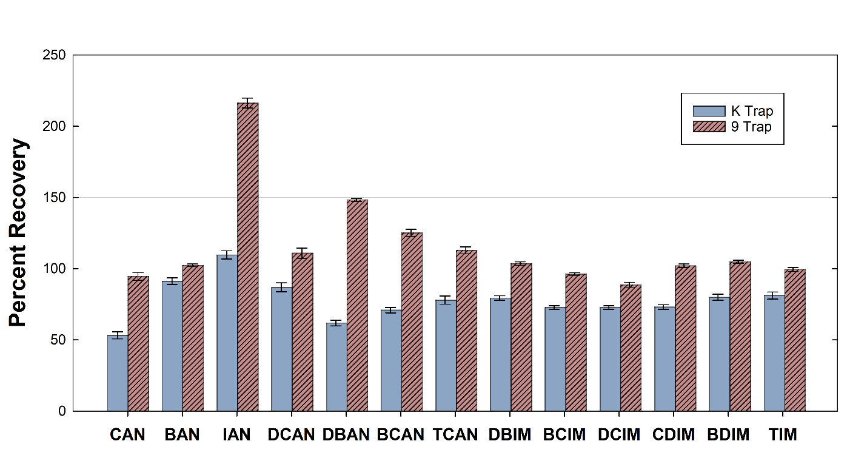

Figure 1. HANs and ITHMs percent recovery (standard deviation) from K and 9 traps. Samples were spiked with 25 µg/L with 5 replicates. Error bars represent standard deviation.

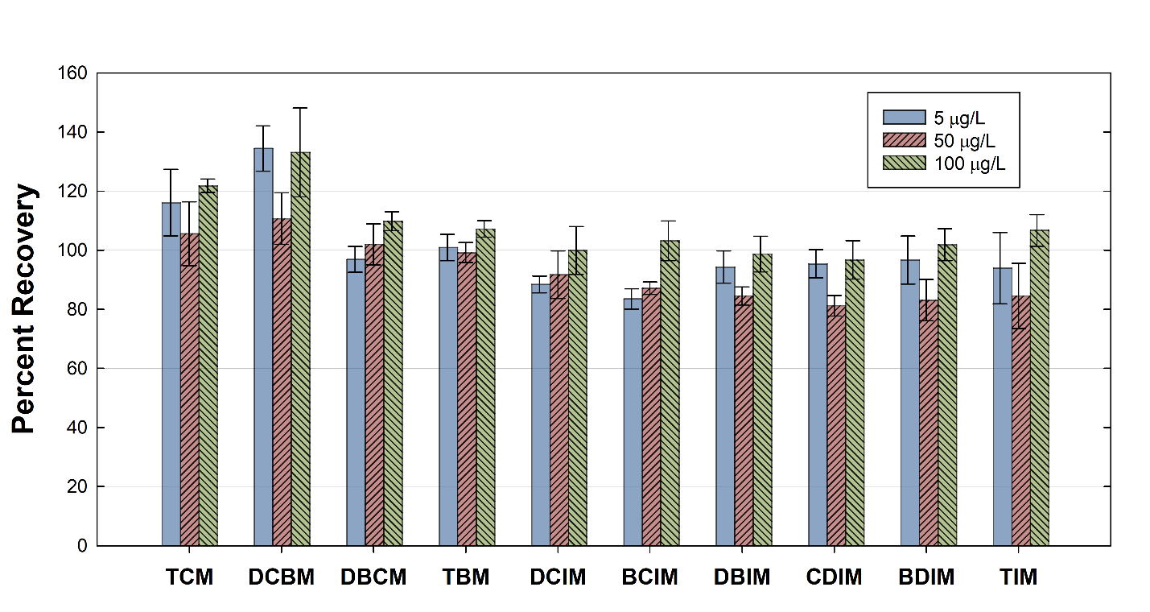

Figure 2: Average percent recoveries for replicate DBP spikes of 5, 50 and 100 µg/L (n = 5) for THMs and I-THMs. Error bars correspond to standard deviation.

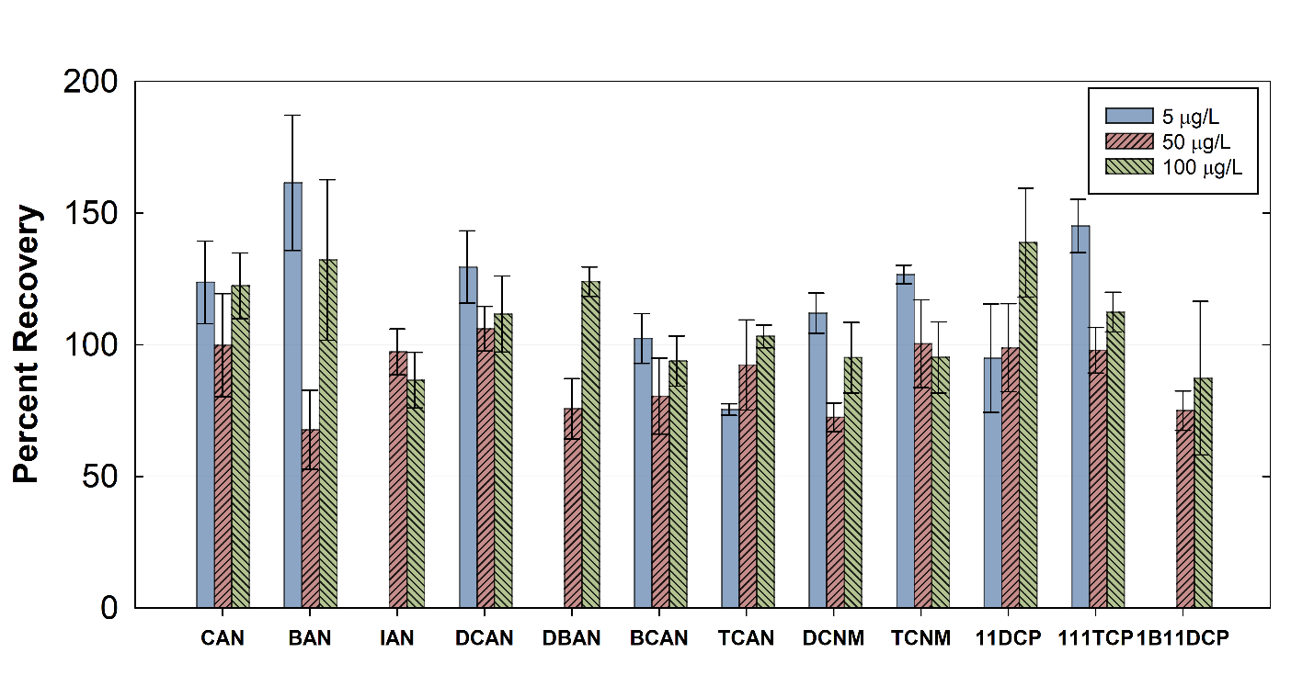

Figure 3 Average percent recoveries for replicate DBP spikes of 5, 50 and 100 µg/L (n = 5) for HANs, HKTs and HNMs. Error bars correspond to standard deviation. Data for 5 µg/L spikes are not included for IAN, DBAN and 1B11DCP, as they did not give a response at that concentration.

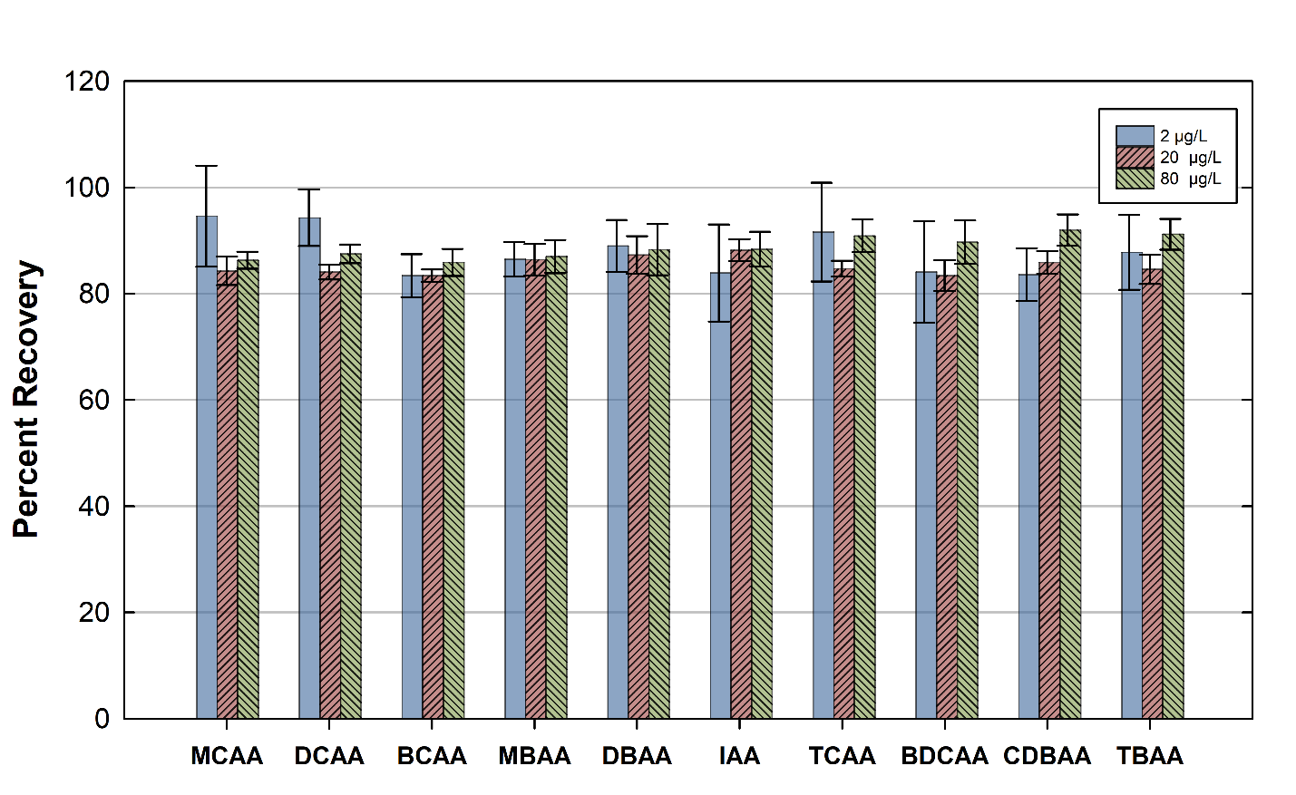
Figure 4. Average percent recoveries for replicate HAA spikes of 2, 20 and 80 µg/L (n = 10). Error bars correspond to standard deviation.

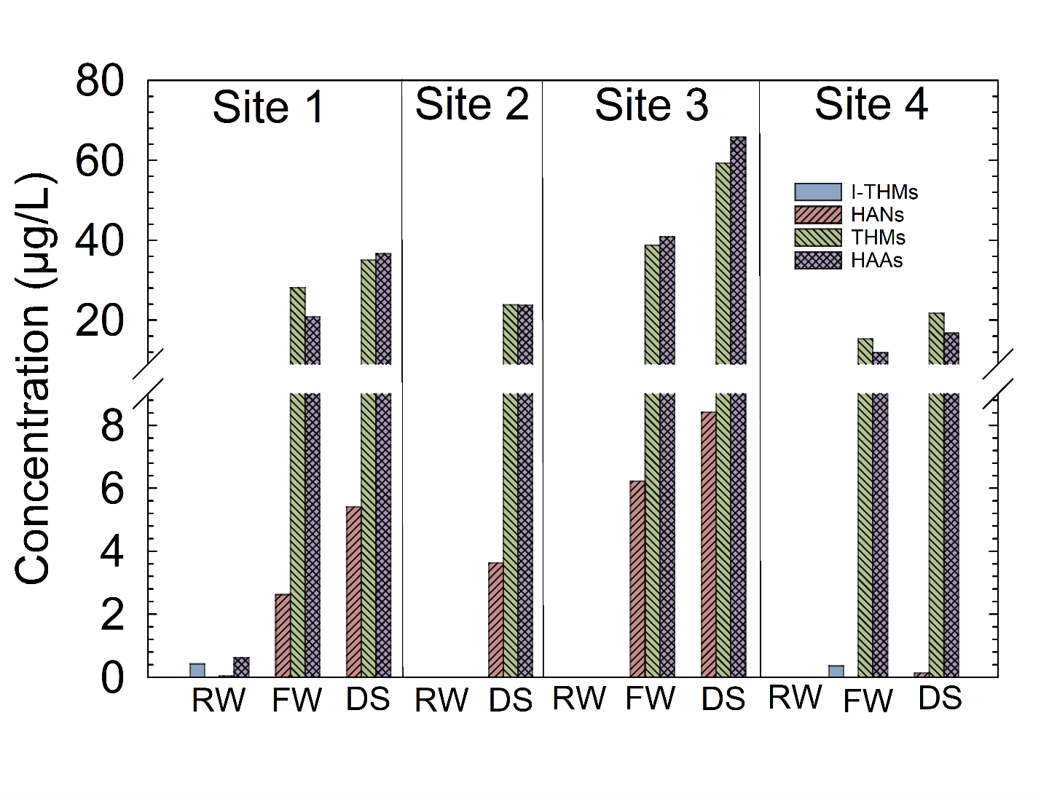
Figure 5. DBP concentrations measured in water samples from sites 1-4 in Alberta. RW= Raw Water, FW = Disinfected Finished Water, DS = Water from Distribution System.

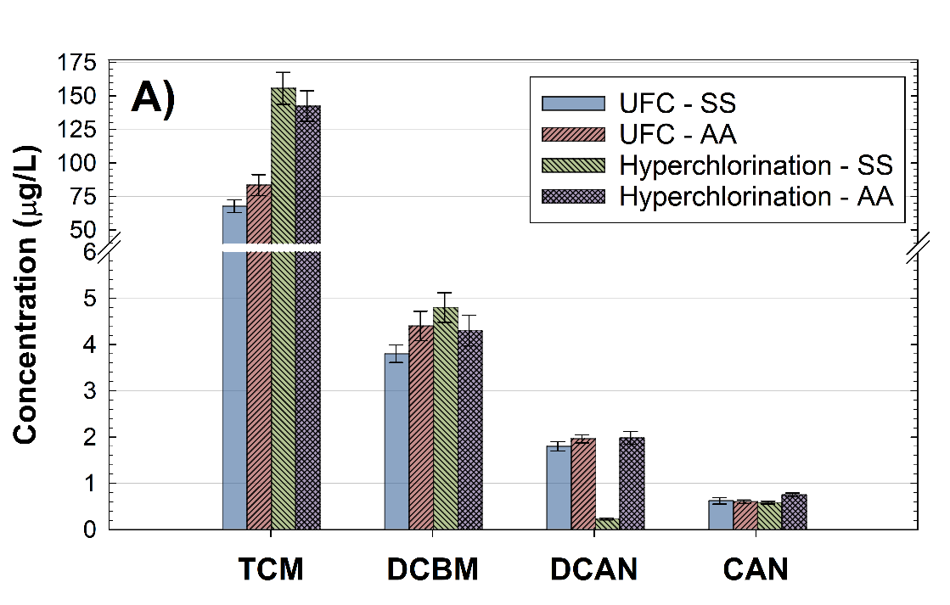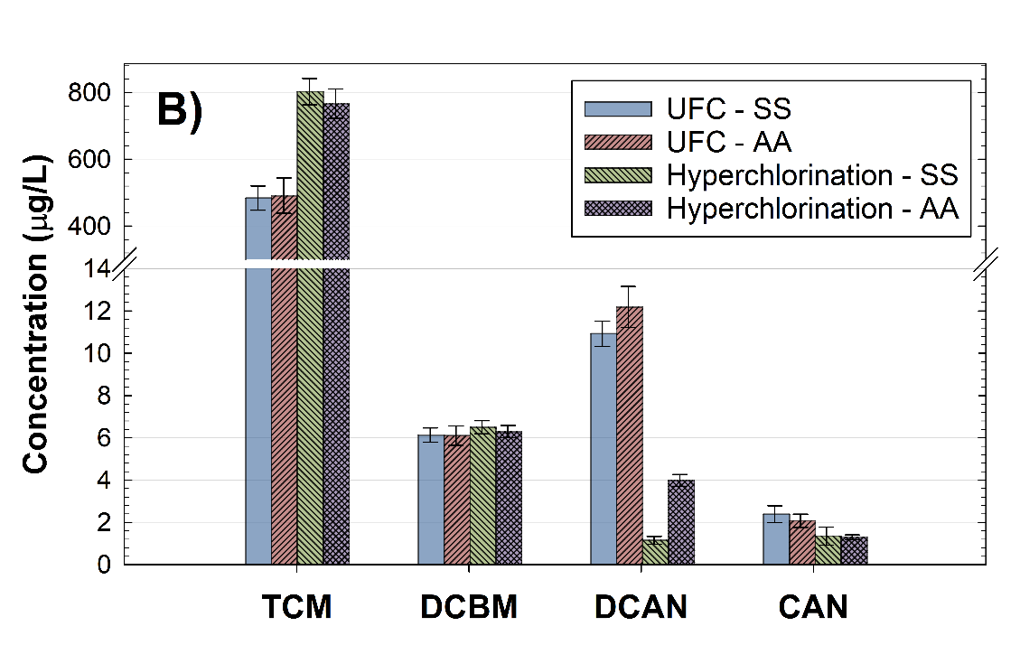

Figure 6: DBP concentrations after formation potential testing of a low TOC sample of 1.7 mg/L (A), and a high TOC sample of 10.8 mg/L (B) using the hyperchlorination and UFC methods, and quenchers of sodium sulfite and ascorbic acid. Error bars represent standard deviation.

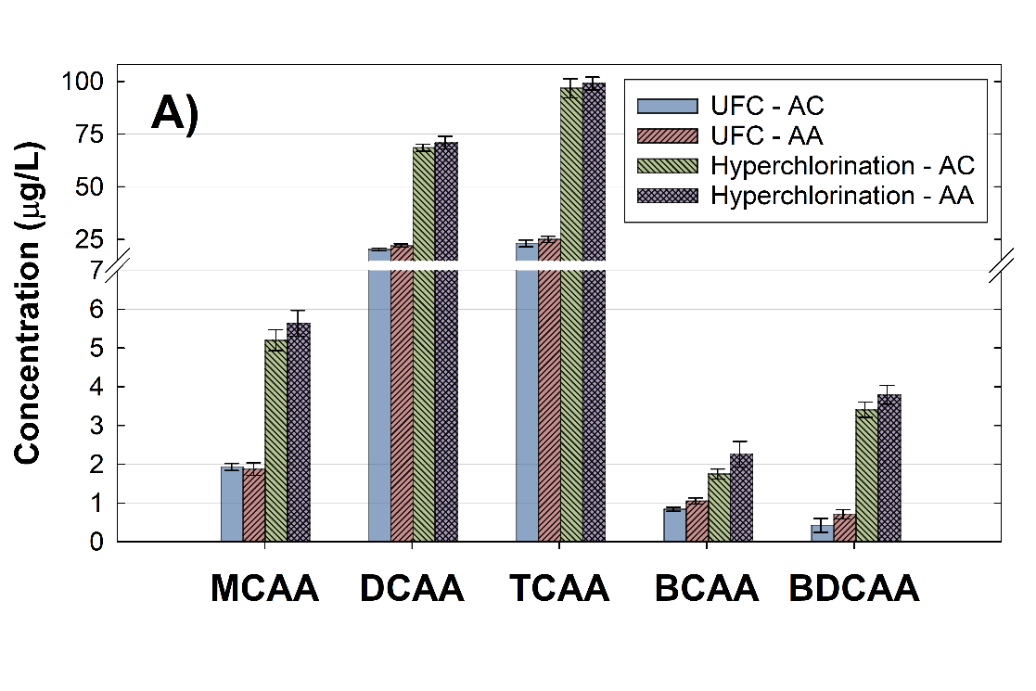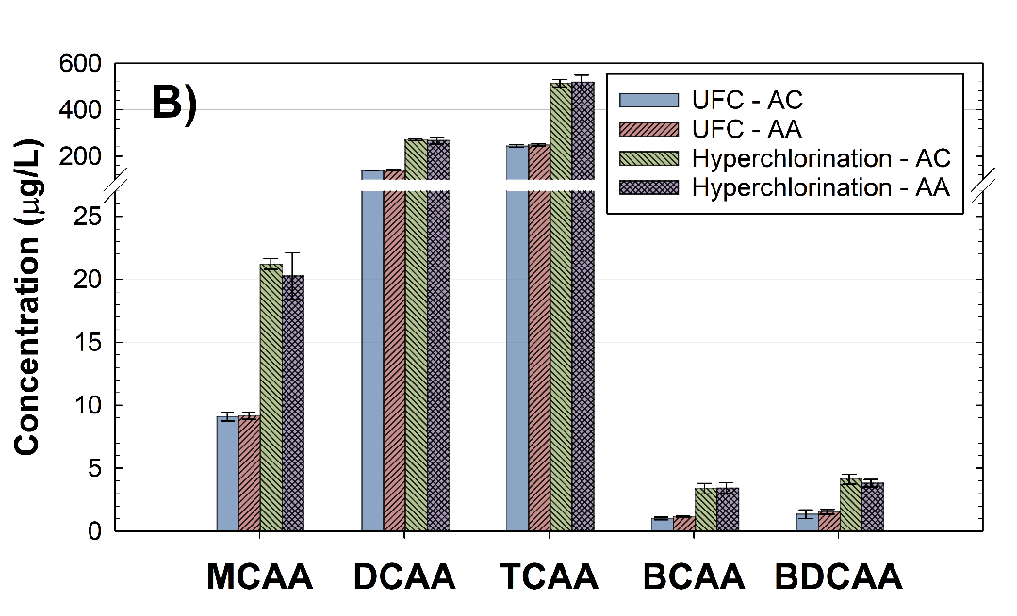

Figure 7. DBP concentrations after formation potential testing of a low TOC sample of 1.7 mg/L (A), and a high TOC sample of 10.8 mg/L (B) using the hyperchlorination and UFC methods, and quenchers of ammonium chloride and ascorbic acid. Error bars represent standard deviation.
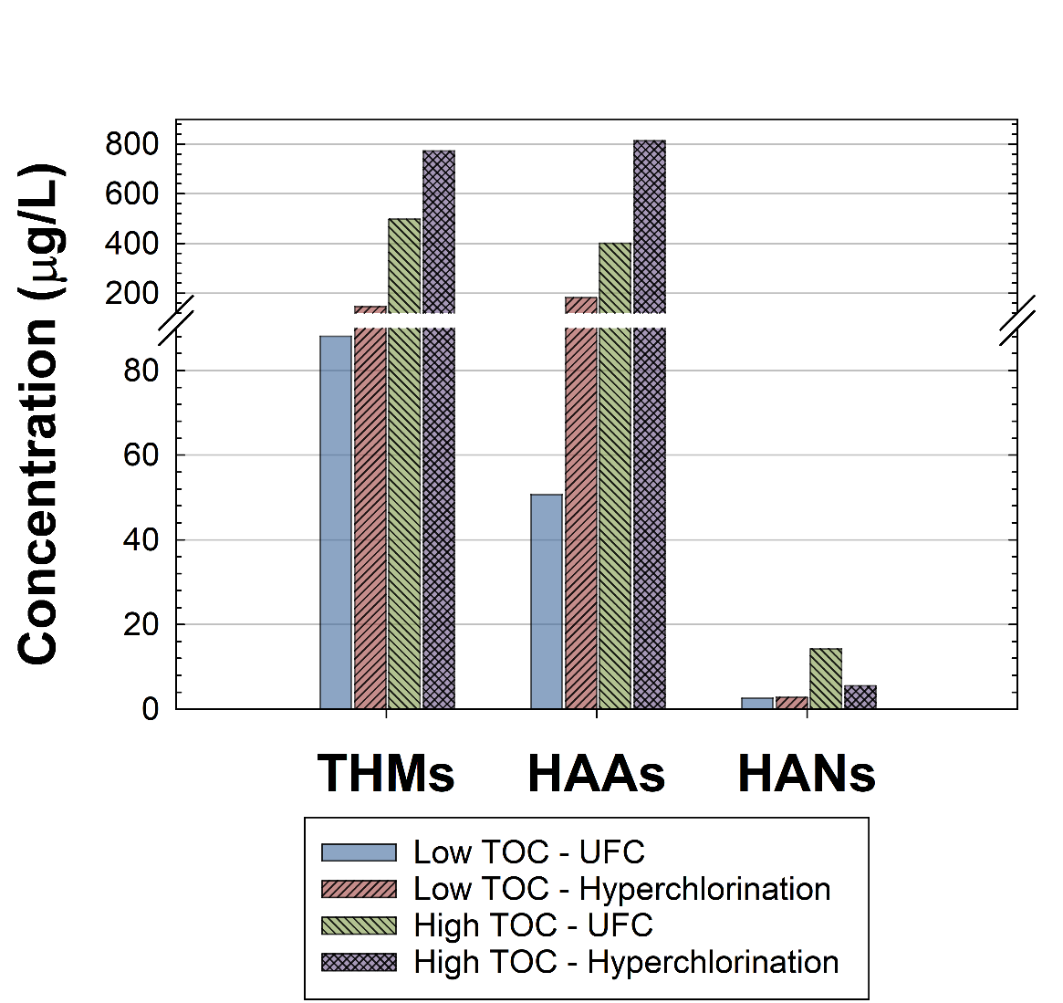
Figure 8. DBP concentrations by DBP class after formation potential testing of a low (1.7 mg/L) and high (10.8 mg/L) TOC samples using the hyperchlorination and UFC methods.

