Haloacetonitrile stability in cell culture media used in in vitro toxicological studies

Thilina K. Jayawardana¹, Md Fahim Hossain¹, Dhruvin Patel¹, Susana Y. Kimura¹
¹University of Calgary, Department of Chemistry, 2500 University Dr. NW, Calgary, AB T2N 1N4, Canada

ABSTRACT
Haloacetonitriles (HANs) are an emerging class of nitrogenous disinfection by-products (DBPs) formed in disinfected drinking water and have been reported to be more cyto- and genotoxic than the regulated DBPs. HANs are also known to hydrolyze under neutral pH and normal room temperature. However, the stability of HANs has not been well characterized in DBP toxicological assessments. Most toxicological assessments expose DBPs up to several days which may result in a mixture of HANs and degradation products that might have underestimated HAN toxicity. In this study, HANs stability was characterized in 1) a buffer solution in sealed vials, 2) cell culture media (CCM) in sealed vials, and 3) CCM in 96 sealed well plates with 5% CO₂. Solutions were incubated at 37°C for 3 days. MonoHANs were found to be stable in buffer and CCM except when HANs were incubated in CCM in plates where they could possibly be affected by volatilization and photodegradation during sample handling. However, di- and tri- HANs degraded between 70-100% in both buffer solution and CCM. They were also found to be less stable in CCM than in buffer solution possibly from HANs reacting with nucleophiles present in CCM (i.e., amino acids). Identified degradation products include corresponding haloacetamides and haloacetic acids for buffer solutions and only haloacetic acids and an unknown brominated compound for CCM. Results of this study suggests that reported toxicity values might have been underestimated and should consider changing CCM and DBP on a daily basis for a more accurate toxicity measurement.

Keywords:
disinfection byproducts, haloacetonitriles, cell culture media, hydrolysis, haloacetamides, haloacetic acids
License: CC-BY-NC-ND; https://doi.org/10.1016/j.chemosphere.2022.137568

- Introduction

Water disinfection is a crucial step in drinking water treatment that has significantly reduced water borne diseases such as diarrhea, cholera, dysentery, and typhoid. Chemical disinfectants used to inactivate pathogens can also react with organic and inorganic compounds present in source waters and form disinfection by-products (DBPs). Source waters with different water quality characteristics such as organic matter and pH may affect DBPs formation. Although more than 700 DBPs have been identified in disinfected drinking water, primarily trihalomethanes and haloacetic acids (HAAs) are regulated or monitored in most countries (Krasner et al., 2006; Richardson et al., 2007; Richardson, 2011; Richardson and Kimura, 2016; Richardson and Kimura, 2020; Richardson and Postigo, 2016; Richardson and Ternes, 2018; Richardson and Ternes, 2022). Additionally, 100 aromatic DBPs (Yang et al., 2019) and thousands of individual aromatic DBP formulas have been identified in disinfected waters (Gonsior et al., 2014). Recent studies have shown that aromatic DBPs (Han et al., 2021) and nitrogen-containing DBPs (Allen et al., 2022) have higher toxicity than regulated DBPs. Allen et al. reported that HANs, particularly disubstituted HANs, have a significant impact on the overall drinking water cytotoxicity and proposed them as a potential metrics to measure overall water toxicity (Allen et al., 2022).
HANs are ubiquitous in disinfected drinking water (Richardson, 2011). A maximum total concentration of 4 HANs of 41 µg/L has been reported in a large occurrence study (U.S. EPA ICR) that included 296 public utilities (McGuire et al., 2002). Furthermore, in another large occurrence study dichloroacetonitrile (DCAN) was the most frequently detected HANs with the highest concentration of all 9 HAN species, followed by the two other dihalogenated acetonitriles, bromochloroacetonitrile (BCAN) and dibromoacetonitrile (DBAN) (Krasner et al., 2006; Weinberg et al., 2002). Chloroacetonitrile (CAN), bromoacetonitrile (BAN) and trichloroacetonitrile (TCAN) were quantified at lower concentrations with less frequency. Although the concentration of HANs in drinking water is low, studies have shown that their cytotoxicity and genotoxicity are up to two orders of magnitude higher than regulated HAAs (Muellner et al., 2007; Plewa et al., 2007). Additionally, an index that combines DBP concentration and toxicity potency (LC₅₀) in disinfected drinking waters has shown that HANs are primarily responsible for the in vitro total cytotoxicity (Allen et al., 2022; Plewa et al., 2017). Wei et al. recently performed a comprehensive analysis of HAN toxicity in Chinese hamster ovary (CHO) cells and found cytotoxicity in order of tribromoacetonitrile (TBAN) ≈ DBAN > BAN ≈ iodoacetonitrile (IAN) > BCAN ≈ CDBAN > BDCAN > DCAN ≈ CAN ≈ TCAN and genotoxicity in the order of IAN ≈ TBAN ≈ DBAN > BAN > CDBAN ≈ BDCAN ≈ BCAN ≈ CAN ≈ TCAN ≈ DCAN (Wei et al., 2020). Exposure to HANs can cause abnormal number of chromosomes (Komaki et al., 2014), upregulation of DNA repair gene expression (Attia et al., 2014), and oxidative DNA damage (Attia et al., 2014), all of which are linked with carcinogenicity (Broustas et al., 2014; Kou et al., 2020; Loft et al., 1996; Reuter et al., 2010). HANs also produced DNA strand breaks in human cancerous cell lines, mammalian cells, and adult zebra fish (Daniel et al., 1986; Lin et al., 2016; Muellner et al., 2007; Muller-Pillet et al., 2000; Plewa et al., 2007).
HANs are volatile and metastable compounds that degrade via neutral and base-catalyzed hydrolysis as shown in Figure 1 (Glezer et al., 1999; Jones, 2005; Reckhow et al., 2001; Yu and Reckhow, 2015). Water is a nucleophile that attacks the nitrile carbon (electrophile) to produce haloacetamides (HAMs) as an intermediate which subsequently degrade to HAAs (Glezer et al., 1999; Yu and Reckhow, 2015). HAN hydrolysis rate increases with higher pH, higher number of halogen substitutions at the α-carbon, and higher number of chlorine versus bromine substitutions (Glezer et al., 1999; Reckhow et al., 2001; Yu and Reckhow, 2015). For example, Yu et al. observed that trisubstituted TCAN instantly hydrolyzes at pH 6 and 7 while monosubstituted HANs remain nearly stable at all pH conditions (Yu and Reckhow, 2015). HAMs were also observed to further hydrolyze to HAAs, but at a much slower rate. Therefore, HAMs were predominantly observed for pH 6-8. The stability of HANs decreases in the order of BAN > CAN > DBAN > BCAN > DCAN > BDCAN > TCAN. HAN may also volatilize from solution into headspace due to their relatively high partial pressures (0.71-68.9 Torr) (Postigo et al., 2022) and their volatility depends on the number and type of halogen substitution. In general, volatility is in the order of tri- > di- > mono- HANs and Cl > Br > I (Postigo et al., 2022). Also, HAN loss due to volatilization is affected with increasing temperature.
Although it is well known that HANs hydrolyze under drinking water conditions, the stability of HANs under cell culture conditions (37°C, pH 7.4, 5% CO₂) used in in vitro toxicological studies has not been well characterized. Therefore, it is uncertain if the initial HAN concentration remains constant throughout the experiment. This leads to concerns regarding in vitro toxicity studies. Are the observed effects from in vitro studies the result of HANs or its hydrolyzed products? Does the cell culture media (CCM) accelerate or hinder HAN degradation? The objectives of this study are to (1) understand the level of degradation of HANs in CCM and a buffer solution with the same pH and buffer concentration found in CCM and (2) identify the HAN degradation products in buffered solutions and in CCM. We hypothesized that HANs would be unstable and hydrolyze under cell culture conditions. Solid phase microextraction (SPME) was used to evaluate HAN in both solutions, which is a particularly good method to analyze semi-volatiles in complex matrices. Results from this research will help determine the main compounds found in CCM after incubation that may provide insights for an improved study design.
2. Material and Methods

2.1. Reagents and solutions

Analytical standards for DBPs used in this study were obtained as a solution of their highest purity as shown in Table 1 and S1 in SI. Sodium phosphate monobasic, sodium phosphate dibasic (anhydrous ≥99%), sodium bicarbonate (≥99.7%), sodium sulfate (anhydrous ≥99%), dimethyl sulfoxide (DMSO, Molecular Biology Grade), and 85 µm carboxen-polydimethylsiloxane (CAR/PDMS) SPME fiber were purchased from Sigma-Aldrich (Saint Louis, MO, USA). Methyl tert-butylether (MTBE) (99.9%) was purchased from Acros Organics (New Jersey, NJ, USA). LC Optima grade methanol (MeOH), acetonitrile (ACN), and water were obtained from Fisher Scientific (New Hampshire, USA). Dulbecco’s Modified Eagle Medium Nutrient Mixture F-12 (DMEM/F-12) was bought from Lifetech (Burlington, ON, Canada). CCM for this study consists of DMEM/F-12, 10% fetal bovine serum and 0.01mg/mL Hygromycin B. Ultrapure water (≥18.1 MΩ) was obtained from a Barnstead MicroPure system (Thermo Fisher Scientific, USA).

A buffer solution that mimics DMEM/F-12 was prepared by adding 2438 mg/L sodium bicarbonate, 71.02 mg/L sodium phosphate dibasic anhydrous and 62.5 mg/L sodium phosphate mono basic in ultrapure water. pH was adjusted to 7.4 with 1 M sulfuric acid.
CAN, BAN, IAN and DCAN standard stock solutions (~200-400 mM) were prepared individually in DMSO. A 10 mM HAN mixture (either mono-, di-, or tri-HANs) was prepared daily in DMSO. A 5 mM internal standard (ISTD) solution was prepared by diluting 1,2-dibromopropane in DMSO.

2.2. Stability of Haloacetonitriles
The stability of 8 haloacetonitriles in buffer solution and CCM were evaluated for a period of 3 days. A 3 day incubation period was selected because most in vitro toxicological models that evaluate HANs use DBP cell exposure between 1 to 3 days (Lu et al., 2018; Luo et al., 2017; Muellner et al., 2007; Park et al., 2021; Wagner and Plewa, 2017). Mono-, di- and tri- HAN mixtures were spiked into 20 mL amber vials that contained 12 mL of buffered solution or CCM. For each haloacetonitrile mixture, 4 vials in triplicate (total of 12 per experiment) were prepared on Day 0 and incubated at 37°C in an oven (Isotemp Incubator, Fisher Scientific). Samples were extracted on Day 0, 1, 2 and 3. HANs and ISTD concentration in each sample were 10 µM and 5 µM, respectively. pH was 7.4 for both buffer solutions and CCM.
HAN stability under cell culture conditions was also tested. CCM spiked with 10 µM HANs were prepared in 20 mL amber bottles and transferred to 200 µL-96 well plates (Corning Inc. 3603, Glendale, AZ). Each plate was sealed with a AlumaSeal CSTM sterile adhesive sealing foil (Excel Scientific, Victorville, CA, USA) to minimize volatilization prior to placing lids. Samples were incubated in a Heracell 150i incubator (Thermo Scientific, Waltham, MA, USA) at 37°C and 5% CO₂ for three days. After three days, 12 mL of sample were pooled together into 20 mL amber vials and extracted immediately as described below.

2.3. Sample extraction and GC-MS/MS analysis
Samples were extracted using SPME. Prior to extraction, 3.6 g of sodium sulfate was added to spiked solutions. Vials were immersed in a water bath at a constant temperature of 40°C (Kristiana et al., 2012) that was heated using a hot plate stirred at 600 rpm. Sample extraction times were tested (15, 20 and 30 min). SPME fibers were exposed using a manual syringe at the appropriate needle depth by adjusting the black needle guide/depth gauge so that the top is at 1.6 on the vernier gauge on the holder. SPME fiber was immediately desorbed manually in a gas chromatography injection port. Desorption temperatures (200, 250, and 275°C) and times (2.3, 2.6 and 3.0 min) were also evaluated. A blank was performed prior to experiments and/or after three consecutive samples.
HANs were analyzed using an Agilent 7890B GC with a multi-mode inlet (MMI) coupled to a 7000C Agilent triple quadrupole mass spectrometer (Agilent Technologies, Santa Clara, CA). The GC column used in this study was a VF-200 MS column (15m, 0.25 mm ID, 0.25 µM df, Agilent) containing trifluoropropyl stationary phase. Helium was the carrier gas. SPME fiber was manually injected into an inlet port injector and desorbed for 3 mins at 250°C, splitless mode, at a constant flow of 1.38 mL/min. Oven was initially held at 25°C for 5 min, ramped at 90°C/min to 200°C, followed by a second ramp of 15°C/min to 280°C. HANs were analyzed under multiple reaction monitoring (MRM). Quantification ions are reported elsewhere and shown in Table 1. HAN stability was analyzed by comparing relative peak areas (ratio of peak area of the HAN to ISTD) of each day to day 0.
Method detection limits (MDLs) are the lowest analyte concentration that can be detected with 99% confidence (Harris, 2003; Wells et al., 2011). MDLs were determined by spiking 1 μg/L of all HANs into ultrapure water followed by the extraction procedure previously described. MDLs were calculated by multiplying the standard deviation of seven replicates by the one-sided Student’s t-value at 99% confidence interval with 6 degrees of freedom (Kimura et al., 2019; Murakami et al., 2022; Ortega-Hernandez et al., 2021). TBAN was not evaluated because the commercial standard was no longer available when MDLs were determined.
2.4. Compound identification with ESI-MS/MS
HAN degradation products were identified from individually spiked samples (0.2 mM concentration) in buffer solution and CCM. Spiked samples were incubated at 37°C and extracted after 3 days. The 20 mL incubated sample was prepared in a 40 mL amber borosilicate bottle with a polytetrafluoroethylene (PTFE)-lined polyethylene cap. A modified liquid-liquid extraction method was employed to extract samples from buffer solutions (Zhai and Zhang, 2009; Zhang et al., 2008). Samples were extracted with and without acidification prior to liquid-liquid extraction to maximize the extraction of carboxylic acids and acetamides, respectively. Samples were acidified by adjusting the pH < 1.5 with 5–6 drops of concentrated sulfuric acid. Then, 2 mL of MTBE and 2 g of sodium sulfate were added and shaken vigorously for 3 min using a Burrel wrist action shaker (Pittsburgh, PA, U.S.A). Samples were allowed to settle for 3 min for the organic layer to separate. The top organic layer was removed and evaporated to 1 mL under a gentle nitrogen gas flow (1.0 L/min) with a Biotage TurboVap® II (Uppsala, Sweden). Extracts were solvent exchanged by adding 15 mL of acetonitrile and evaporated again to 1 mL. Final extracts were diluted with 1 mL of LC Optima grade water and analyzed with ESI-MS/MS analysis. Sample blanks and reference standards diluted in water were also prepared by the same procedure to determine any impurities or artifacts from the extraction procedure.
To evaluate HAN degradation products in CCM, 1 mL of spiked CCM was incubated in 2 mL GC amber vial at 37°C and 5% CO₂ for three days. At the end of three days, the sample was transferred to a 15 mL falcon tube and mixed with 1 mL of pre-chilled LC grade methanol. The sample was incubated on ice for 30 min and shaken every 10 min using a Burell wrist-action shaker (Pittsburgh, PA, USA). After incubation, the sample was centrifuged (Eppendorf Model 5702, Mississauga, Canada) at 4200 rpm for 10 mins. About 1 mL of supernatant was transferred to a new 15 mL falcon tube, kept at -20⁰C for one hour, and centrifuged again at 4200 rpm for 10 min to remove protein precipitates. After centrifugation, 0.6 mL of supernatant was transferred to a new 15 mL falcon tube and mixed with 5.4 mL of 1:1 methanol/water solution.
Individual reference standards were weighted and diluted in methanol to prepare ~1000 mg/L stock solution. A working standard of 200 mg/L was prepared daily by diluting stock solution in 1:1 ratio of organic solvent (acetonitrile or methanol) to water prior to use. Finally, an individual 1 mg/L reference standard was prepared by diluting the working standard with 1:1 organic solvent:water for ESI-MS/MS analysis.
Reference standards and extracted samples were directly infused into a Waters Xevo TQ-S micro triple quadrupole mass spectrometry (Milford, MA, USA) fitted with a Z-spray (dual orthogonal sampling) for electrospray ionization (ESI). MassLynx 4.1 software (Waters Corp.) was used for data acquisition and control systems. Waters Xevo TQ-S micro parameters were optimized using available HAMs and HAAs standards listed in Table S1 in Support Information (SI). HAMs and HAAs were selected as possible HAN hydrolysis products and intermediates. Positive and negative ESI were employed to maximize the ionization efficiency of molecular ions of HAMs and HAAs standards. After using both ionization methods, negative ion (-) ESI showed better peak intensity, high resolution, and low background noise for HAMs and HAAs standards. The instrument tune page (MS Tune) was used for manual tuning, and the optimized operation parameters were as follows: Sample infusion flow rate was 10 μL/min; ESI mode, negative ion (-); Capillary voltage, -2.0 kV; Cone voltage, -10V; Ion source temperature, 150°C; Desolvation temperature, 400°C; Collision gas (argon) in the collision-induced decomposition (CID) source, 10 psi; Desolvation gas (850 L/h) and cone gas (35 L/h) chambers were filled with high-purity nitrogen. Parent ion scan (PIS) was used to identify polar halogenated DBPs according to published methods (Zhang et al., 2005; Zhang et al., 2008a). Briefly, PIS of m/z 35 and 37 was used for chlorinated DBPs and PIS of m/z 79 and 81 was used for brominated DBPs.

- Results and Discussion
3.1. SPME conditions
A 85 µm CAR/PDMS SPME fiber was chosen for this study because it had shown good performance on the extraction of short (Boadas-Vaello et al., 2008; Kristiana et al., 2012; Luo et al., 2014) and/or iodinated nitriles (data not shown). SPME conditions were tested only on the monoHANs. Results for SPME conditions tested are shown in Figure 2. An increase in GC-MS/MS response (peak area) was observed with increasing extraction time for all three HANs (Figure 2a). CAN, BAN, and IAN had a 48%, 221%, and 331% increase from 15 to 30 min, respectively. Therefore, a 30 min extraction time was selected. A higher extraction time was not tested because according to Luo et al. 2014, increasing the extraction time from 30 to 40 min did not significantly increase the extraction efficiencies for CAN, BAN and DCAN.
Results for desorption temperature and time are shown in Figure 2b and 2c. BAN and IAN peak areas increased by 69% and 21% when the temperature was increased from 200°C to 250°C, respectively (Figure 2b). However, when temperature was increased to 275°C the signal for these two HANs was reduced. Possibly, at higher temperatures, BAN and IAN might have undergone thermal degradation. Conversely, CAN peak area did not differ significantly with increasing temperature. Therefore, 250°C was selected as the optimum desorption temperature.
CAN and BAN signal increased by 87% and 22% respectively when desorption time was increased from 2.3 mins to 3.0 mins (Figure 2c). However, IAN signal decreased by 20% between these two desorption times. However, since two of the three monoHANs exhibited higher sensitivity with the increasing desorption time, 3.00 min was chosen as the desorption time.
Method detection limits were tested with the selected final conditions: 30 min extraction and 3 min desorption time at 250°C. MDLs were found between 0.358-0.962 µg/L (Table 1). MDLs were slightly higher than those reported in other studies that used SPME (2-50 ng/L, Luo et al., 2014; Kristiana et al., 2012). However, IAN was not included in previously reported studies, but its MDL was determined to be 0.358 µg/L in this study.
3.2. Stability of HANs
The stability of eight HANs were individually evaluated in sealed vials that contained buffer solution or CCM at 37°C. Additionally, HANs were evaluated under cell incubation conditions used for alamarBlue assay (Nakayama et al., 1997; O’Brien et al., 2000; Page et al., 1993), a bioassay used by our laboratory to measure HAN cytotoxicity (unpublished results). Cell incubation conditions consisted of 96 well plates sealed with alumina seal and incubated at 37°C with 5% CO₂. Results are shown in Figures 3, 4, and 5.
MonoHANs (CAN, BAN, IAN) were found to be stable in buffer solution (Figure 3). These results agree with other studies where monoHANs remain stable for period of days under drinking water conditions (Glezer et al., 1999; Yu & Reckhow, 2015). In CCM, CAN was found to be stable however, BAN and IAN were stable for two days followed by a 8% and 25% decrease, respectively on day 3. When HANs were incubated in CCM in plates, it was observed that concentrations of CAN and IAN decreased 60% and 82%, respectively after 3 days (Figures 3A and 3C). BAN was stable throughout the incubation period. The lower CAN concentration could possibly be attributed to an increased volatilization caused by the higher incubation temperature (37°C) and from sample transfer from DBP stock solutions to the plate and back to vials for SPME extraction. However, this could not explain the decrease in IAN concentration. Chen et al showed that the photolysis rate constant (adjusted for hydrolysis) increased in the order of CAN (3.8 x10⁻³ h⁻¹) < BAN (9.3 x10⁻³ h⁻¹) < IAN (4.13.8 x10⁻² h⁻¹) (Chen et al., 2010). IAN photolysis rate constant is 11 and 2.5 times faster than CAN and BAN, respectively. Therefore, IAN could have photodegraded during sample transfer. Although strong efforts were made to minimize HAN loss during sample transfer, it was not possible to eliminate it. For these reasons, HAN stability studies were also conducted in sealed amber vials to minimize artifacts from volatilization and photodegradation.
DiHANs were less stable compared to monoHANs (Figure 4). In buffer solution, DBAN was the most stable followed by BCAN and DCAN. After 3 days, DCAN, DBAN and BCAN degraded 95%, 70 % and 86 %, respectively. These results also agree with previous studies where HAN stability decreased for compounds with higher chlorine-substitution (Glezer et al., 1999; Yu & Reckhow, 2015). Although HANs could have volatilized in the vial, all vials were prepared and sealed on Day 0 and would have remained in the vial until their extraction. Therefore, HAN loss is primarily due to hydrolysis. DiHANs were found to be slightly less stable in CCM than in buffer solution. The stability in CCM followed the same trend as found in buffer solution: DBAN was the most stable followed by BCAN and DCAN. After 1 day, DBAN, BCAN and DCAN degraded 40%, 68%, and 85%, respectively. At the end of the 3 day exposure, DCAN and BCAN degraded completely and only 2% of the initial DBAN concentration was retained in CCM.
DiHANs when incubated in CCM and in plates exhibited lower concentrations for Day 1 and 2 compared to incubated in vials (Figure 4). However, for day 3, DCAN, DBAN and BCAN degraded 99.8%, 94.9% and 98.7% respectively, values similar in range to diHANs incubated in CCM in vials (97.8–99.9%). Initially, it was hypothesized that the solution pH might have a significant effect on HAN hydrolysis. However, pH results plotted in Figure S1 in Support Information (SI) do not support this hypothesis. Solutions incubated in sealed vials with buffer (7.59 ± 0.21) had slightly higher pH than those incubated in CCM (7.47 ± 0.07). Additionally, solutions incubated in sealed plates with 5% CO₂ exhibited stable pH values overtime (7.42 ± 0.04). Therefore, the lower HAN concentration in CCM compared to buffer solutions is attributed to reactions between HANs and nucleophiles contained in CCM, not to pH variation.
TriHANs concentrations were also found to be significantly lower than di- and mono-HANs in both buffer solution and CCM (Figure 5). In the buffer solution, TCAN and TBAN concentration loss was 79% and 62% after two days, respectively. However, by day 3, TCAN and TBAN loss was 88% and 94%. TCAN was found in other studies to instantly hydrolyze at slightly different conditions (20°C and pH 7) where 75% TCAN degradation was observed after 3 days (Yu & Reckhow, 2015). Considering that the temperature and pH were higher in this study, it is expected that HAN loss would be slightly higher. Similar to the trends observed for diHANs, TCAN and TBAN were slightly less stable in CCM (90-99% degradation) compared to the buffer solution. Additionally, TCAN in CCM incubated in plates was undetectable after a day, which was significantly lower compared to CCM in vials alone (Figure 5A). This might be attributed to loss during sample transfer and the high volatility of TCAN.
These results suggest that the HAN main degradation pathway is hydrolysis. However, the slightly higher degradation in CCM suggests that di- and tri- HANs may also be reacting with amino acids (7.25 mM) present in CCM. HANs are electrophiles that can undergo nucleophilic substitution (Lin et al., 1986; Prasse 2021; Roberts et al., 2010). A nucleophile, such as amino acids, can either displace a halogen atom, or attack the partial positive carbon atom of the nitrile that is stabilized by resonance. Furthermore, increasing electron-withdrawing substituents on the α-carbon of HANs may increase the reaction rate of nucleophilic addition toward the nitrile group (Lin et al., 1986). For these reasons, we observe that the stability of diHANs and triHANs in CCM are lower compared to monoHANs. Lin et al. (1989) studied the reactivity of HANs with glutathione (GSH) in the presence and absence of bovine serum albumin and found that TCAN has a higher selectivity towards nucleophilic centers contained in bovine serum albumin (particularly proteins with thiol groups) compared to GSH.
Many in vitro cytotoxicity studies incubate DBPs and cells between 1- 3 days (Lu et al., 2018, Luo et al., 2017, Muellner et al., 2007, Park et al., 2021 Wagner and Plewa, 2017, Wei et al., 2020). Although it is well known that HANs undergo hydrolysis even at neutral pH conditions, to the best of our knowledge this is the first time HAN stability has been assessed in CCM under cell culture conditions. Results of this study showed that di- and tri- HANs significantly degrade in a 3-day incubation period in buffer solution and CCM in sealed vials (incubated at 37°C), and in CCM in 96 sealed well plates (incubated at 37°C and 5% CO₂). Therefore, it might be possible that previous toxicity studies underestimated HAN toxicity assuming that HAN degradation products are less toxic, particularly for cytotoxicity. A way to address this issue in future toxicological evaluations is to change the CCM and spike DBPs on a daily basis. A limitation of this study is that HAN stability was not tested in the presence of cells. Different cell models will absorb and metabolize HANs differently which was outside of the scope of this study.
3.3. Identification of HAN degradation products
3.3.1. In the buffer solution
HANs may undergo hydrolysis under neutral to basic conditions to form HAMs and HAAs (Glezer et al., 1999; Yu and Reckhow, 2015). In this study, HAN hydrolysis products were confirmed by individually extracting incubated buffer solutions that contained di- and tri- HANs and comparing them with analytical standards using ESI-MS/MS with parent ion scan (PIS) method. Identification of chlorinated and brominated compounds is based on the natural isotopic abundances. Therefore, the number of halogens contained in a molecule provides different peak patterns in full scan and PIS as shown in Table S1 in SI. (Yang et al., 2019; Zhai and Zhang, 2009; Zhang et al., 2008)
HANs incubated solutions were extracted without acidification and compared to HAM standards. A similar extraction method has been reported for HAMs analysis (Ding et al., 2018; Glezer et al., 1999). DCAN and TCAN produced a m/z 35 PIS mass spectra with clusters m/z 126/128 (ratio 3:1) and 160/162/164 (ratio of 9:6:1), respectively (Figures 6a and 6c). The peak clusters and isotopic distributions matched DCAM and TCAM analytical standards (Figures 6b and 6d). A strong peak cluster at m/z 117/119/121 was present for TCAM, yielding a mass difference of m/z 43. This may be attributed to the loss of (–CONH) during ionization that resulted in a Cl₃C– ion. A similar phenomenon was observed for TBAM (Figure S3 c-d in SI). Extracted BCAN solution also degraded into its corresponding BCAM as shown in Figure S2 a-b in SI. BCAN produced a peak cluster at m/z 170/172 with PIS of m/z 79 (ratio 3:1) and 35 (ratio 1:1). This finding matched with BCAM analytical standard. Results for the extracted DBAN and TBAN solutions are shown in Figure S3 in SI. Major clusters were found at m/z 214/216 (ratio 1:1) and 249/251/253 (ratio 1:2:1) and matched with DBAM and TBAM analytical standards, respectively. The peak cluster for TBAM was observed at m/z 249/251/253 instead of m/z 292/294/296. TBAM might have lost (–CONH) resulting in a Br₃C– ion at m/z 249/251/253.
HANs can also degrade to HAAs (Figure 1). Incubated solutions were acidified to pH <1.5 before extraction for HAAs to partition to the organic layer (pKa values of 0.7-2.9) (Zhai and Zhang, 2009). Results for extracted samples and HAA analytical standards are shown in Figures S4-S6 in SI. DCAN and TCAN extracted solutions matched for DCAA and TCAA analytical standards are shown in Figure S4 in SI. However, a peak cluster at m/z 117/119/121 was observed for TCAA instead of an expected peak cluster at m/z 161/163/165, a mass difference of m/z 44. Previous studies have reported that triHAAs are unstable in aqueous solution, and decarboxylation (-CO₂) may occur under ESI (Zhang and Minear, 2002). A similar behavior was observed for TBAA (Figure S6 in SI). Furthermore, extracted solutions of BCAN, DBAN, and TBAN were found to produce BCAA, DBAA, and TBAA, respectively. Figures S5 and S6 in SI provide a match between extracted solutions and analytical standards. Controls were performed to ascertain that HAMs do not produce HAAs as the result of the acidified extraction by extracting HAM reference materials in buffered water. HAAs were not observed (data not shown).
3.3.2. In CCM
Samples containing HANs in CCM were also individually analyzed for degradation products. These samples were treated with methanol to precipitate proteins, centrifuged, and diluted prior to ESI-MS/MS analysis. Results for CCM spiked with 5 mM and 10 mM HANs are shown in Figure S7 and S8 in SI. The isotopic ratio for DCAA (m/z 127/129) and TCAA (m/z 117/119/121) were observed in samples with DCAN and TCAN incubated in CCM, respectively (Figure S7). Similar results were found for BCAN (Figure S8), where only BCAA (m/z 170.8/172.85) was detected. Peaks m/z 171/173 and 215/217 were observed for DBAN, which pertains to DBAA. However, the isotopic ratios are not indicative of bromine (100:97) and might be the result of low concentration of DBAA. Therefore, we could not conclude definitely that DBAA is a degradation product. Additionally, a significant peak was observed at m/z 205 (mono brominated compound) in both brominated diHANs. It might be possible that brominated diHANs might react with compounds present in CCM to form a monobrominated product. However, further investigation is needed to identify this product.
Although HAAs were detected, HAMs were not observed in any of the samples. These results suggest that HANs hydrolyze to HAAs with possibly HAMs as intermediate products. However, it is possible we did not observe HAMs because HAMs, an electrophile, might have also reacted with amino acids in CCM. Therefore, results suggest that HANs incubated in CCM may only form HAAs. Under the conditions used in this study, only one other brominated product was observed as the result of brominated HAN hydrolysis.
- Conclusions
The stability of mono-, di-, and tri- substituted HANs were analyzed in a buffer solution and CCM using SPME and GC-MS/MS. SPME is a good analytical method to evaluate HANs particularly in complex matrices such as CCM. Mono HANs were found to be the most stable in both buffer and CCM when incubated in vials. CAN and IAN degraded when they were incubated in 96 well plates and CCM at 5% CO₂, possibly due to volatilization and photodegradation. Di- and tri- substituted HANs were not stable in all experimental conditions tested in this study and was slightly less stable in CCM compared to buffer solutions. It is possible that HANs (electrophile) might have reacted with other nucleophiles present in CCM (i.e. amino acids, proteins). However, results suggest that the main mechanism for HAN degradation is hydrolysis. HAAs and HAMs were found to be the major HAN degradation products in buffer solutions. Only HAAs were observed in CCM spiked with HANs. Additionally, a monobrominated product was identified from brominated diHANs. These results also suggest that in vitro toxicological studies that employs incubation periods over 1 day might have underestimated HAN toxicity. A possible way to address this issue is to adjust HAN concentration during incubation by changing the CCM and DBPs on a daily basis. Furthermore, this study focused on the stability of HANs, other highly toxic DBPs (i.e., aromatic DBPs) could also be investigated. This study could be extended to analyze the compounds in CCM and its interaction with HANs.
Conflict of interest
There are no conflict of interests.
Acknowledgements
The authors would like to thank Alejandro Ortega-Hernandez for his advice on the GC-MS/MS analytical method, Dr. Jillian Murakami, and Jorge Perez Perez for their kind support during experiments, and Wade White for his support on the GC-MS/MS. The authors would also like to thank Drs. Jurgen Gailer and Aaron Goodarzi for their helpful comments and suggestions. We would also thank Dr. Belinda Heyne and Toni Sikkema for sharing their lab equipment and Dr. Marija Drikic for her help with the CCM extraction. Funding was provided by Natural Sciences and Engineering Research Council (NSERC) Discovery Grant, Canadian Research Chair (CRC), and Canada Foundation for Innovation (CFI).

References
Allen, J M, Plewa, M J, Wagner, E D, Wei, X, Bokenkamp, K, Hur, K, Jia, A, Liberatore, H K, Lee, C T, Shirkhani, R, Krasner, S W, Richardson, S D, 2022. Drivers of Disinfection Byproduct Cytotoxicity in U.S. Drinking Water: Should Other DBPs Be Considered for Regulation? Environ. Sci. Technol. 56:392-402.
Attia, S M, Ahmad, S F, Zoheir, K M, Bakheet, S A, Helal, G K, Abd-Allah, A R, Al-Harbi, N O, Al-Hosaini, K A, Al-Shabanah, O A, 2014. Genotoxic evaluation of chloroacetonitrile in murine marrow cells and effects on DNA damage repair gene expressions. Mutagenesis 29:55-62.
Boadas-Vaello, P, Jover, E, Llorens, J, Bayona, J M, 2008. Determination of cyanide and volatile alkylnitriles in whole blood by headspace solid-phase microextraction and gas chromatography with nitrogen phosphorus detection. J. Chromatogr. B 870:17-21.
Broustas, C G, Lieberman, H B, 2014. DNA Damage Response Genes and the Development of Cancer Metastasis. Radiat. Res. 181:111-130, 120.
Chen, B, Lee, W, Westerhoff, P K, Krasner, S W, Herckes, P, 2010. Solar photolysis kinetics of disinfection byproducts. Water Res. 44:3401-3409.
Daniel, F B, Schenck, K M, Mattox, J K, Lin, E L C, Haas, D L, Pereira, M A, 1986. Genotoxic properties of haloacetonitriles – drinking-water by-products of chlorine disinfection. Fundam. Appl. Toxicol. 6:447-453.
Ding, S, Chu, W, Krasner, S W, Yu, Y, Fang, C, Xu, B, Gao, N, 2018. The stability of chlorinated, brominated, and iodinated haloacetamides in drinking water. Water Res. 142:490-500.
Glezer, V, Harris, B, Tal, N, Iosefzon, B, Lev, O, 1999. Hydrolysis of Haloacetonitriles: Linear Free Enegry Relationship, Kinetics and Products. Water Res. 33:1938-1948.
Gonsior, M., Schmitt-Kopplin, P., Stavklint, H., Richardson, S.D., Hertkorn, N., Bastviken, D., 2014. Changes in Dissolved Organic Matter during the Treatment Processes of a Drinking Water Plant in Sweden and Formation of Previously Unknown Disinfection Byproducts. Environ. Sci. Technol. 48, 12714-12722.
Han, J., Zhang, X., Jiang, J., Li, W., 2021. How Much of the Total Organic Halogen and Developmental Toxicity of Chlorinated Drinking Water Might Be Attributed to Aromatic Halogenated DBPs? Environ. Sci. Technol. 55, 5906-5916.
Harris, D C, 2003. Quantitative Chemical Analysis, 6 ed. Freeman.
Jones, M J, 2005. Organic Chemistry, 3rd ed. Norton&Co: New York.
Kiattisaksiri, P, Khan, E, Punyapalakul, P, Ratpukdi, T, 2016. Photodegradation of haloacetonitriles in water by vacuum ultraviolet irradiation: Mechanisms and intermediate formation. Water Res. 98:160-167.
Kimura, S Y, Cuthbertson, A A, Byer, J D, Richardson, S D, 2019. The DBP exposome: Development of a new method to simultaneously quantify priority disinfection by-products and comprehensively identify unknowns. Water Res. 148:324-333.
Komaki, Y, Marinas, B J, Plewa, M J, 2014. Toxicity of Drinking Water Disinfection Byproducts: Cell Cycle Alterations Induced by the Monohaloacetonitriles. Environ. Sci. Technol. 48:11662-11669.
Kou, F, Wu, L, Ren, X, Yang, L, 2020. Chromosome Abnormalities: New Insights into Their Clinical Significance in Cancer. Mol. Ther. Oncolytics 17:562-570.
Krasner, S W, Weinberg, H S, Richardson, S D, Pastor, S J, Chinn, R, Sclimenti, M J, Onstad, G D, Thruston, A D, 2006. Occurrence of a new generation of disinfection byproducts. Environ. Sci. Technol. 40:7175-7185.
Kristiana, I, Joll, C, Heitz, A, 2012. Analysis of halonitriles in drinking water using solid-phase microextraction and gas chromatography-mass spectrometry. J Chromatogr A 1225:45-54.
Lin, E L, Daniel, F B, Herren-Freund, S L, Pereira, M A, 1986. Haloacetonitriles: metabolism, genotoxicity, and tumor-initiating activity. Environ. Health Persp. 69:67-71.
Lin, E L C, Guion, C W, 1989. Interaction of haloacetonitriles with glutathione and glutathione-S-transferase. Biochemical Pharmacology 38:685-688.
Lin, T, Zhou, D J, Dong, J, Jiang, F C, Chen, W, 2016. Acute toxicity of dichloroacetonitrile (DCAN), a typical nitrogenous disinfection by-product (N-DBP), on zebrafish (Danio rerio). Ecotox. Environ. Safe. 133:97-104.
Loft, S, Poulsen, H E, 1996. Cancer risk and oxidative DNA damage in man. J. Mol. Med. 74:297-312.
Lu, G. H.; Qin, D. H.; Wang, Y. H.; Liu, J. C.; Chen, W., 2018. Single and combined effects of selected haloacetonitriles in a human-derived hepatoma line. Ecotox. Environ. Safe. 163:417-426.
Luo, H.; Zhai, L.; Yang, H.; Xu, L. M.; Liu, J. X.; Liang, H. R.; Tang, H. W., 2017. Dichloroacetonitrile induces cytotoxicity through oxidative stress-mediated and p53-dependent apoptosis pathway in LO2 cells. Toxicol. Mech. Methods 27:575-581.

Luo, Q, Chen, X, Wei, Z, Xu, X, Wang, D, Wang, Z, 2014. Simultaneous and high-throughput analysis of iodo-trihalomethanes, haloacetonitriles, and halonitromethanes in drinking water using solid-phase microextraction/gas chromatography-mass spectrometry: an optimization of sample preparation. J. Chromatogr. A 1365:45-53.
McGuire, M J, McLain, J L, Obolensky, A, 2002. Information Collection Rute Data Analysis. AwwaRF and AWWA, Denver, CO.
Muellner, M G, Wagner, E D, McCalla, K, Richardson, S D, Woo, Y-T, Plewa, M J, 2007. Haloacetonitriles vs regulated haloacetic acids are nitrogen-containing DBPs more toxic. Environ. Sci. Technol. 41:645-651.
Muller-Pillet, V, Joyeux, M, Ambroise, D, Hartemann, P, 2000. Genotoxic activity of five haloacetonitriles: Comparative investigations in the single cell gel electrophoresis (Comet) assay and the Ames-fluctuation test. Environ. Mol. Mutagen. 36:52-58.
Murakami, J N, Zhang, X, Ye, J, MacDonald, A M, Pérez, J, Kinniburgh, D W, Kimura, S Y, 2022. Formation potential and analysis of 32 regulated and unregulated disinfection by-products: Two new simplified methods. J. Environ. Sci. 117:209-221.
Nakayama, G R, Caton, M C, Nova, M P, Parandoosh, Z, 1997. Assessment of the Alamar Blue assay for cellular growth and viability in vitro. J Immunol Methods 204:205-208.
O‘Brien, J, Wilson, I, Orton, T, Pognan, F, 2000. Investigation of the Alamar Blue (resazurin) fluorescent dye for the assessment of mammalian cell cytotoxicity. Eur J Biochem 267:5421-5426.
Ortega-Hernandez, A, Acayaba, R, Verwold, C, Montagner, C C, Kimura, S Y, 2021. Emerging investigator series: emerging disinfection by-product quantification method for wastewater reuse: trace level assessment using tandem mass spectrometry. Environ. Sci.-Wat. Res. Technol. 7:285-297.
Page, B, Page, M, Noel, C, 1993. A new fluorometric assay for cytotoxicity measurements in-vitro. Int J Oncol 3:473-476.
Park, C. G.; Jung, K. C.; Kim, D. H.; Kim, Y. J., 2021. Monohaloacetonitriles induce cytotoxicity and exhibit different mode of action in endocrine disruption. Sci. Total Environ., 761:143316.
Plewa, M J, Kargalioglu, Y, Vankerk, D, Minear, R A, Wagner, E D, 2002. Mammalian cell cytotoxicity and genotoxicity analysis of drinking water disinfection by-products. Environ. Mol. Mutagen. 40:134-142.
Plewa, M J, Muellner, M G, Richardson, S D, Fasano, F, Buettner, K M, Yin-Tak, W, McKague, A B, Wagner, E D, 2008. Occurrence, Synthesis, and Mammalian Cell Cytotoxicity and Genotoxicity of Haloacetamides: An Emerging Class of Nitrogenous Drinking Water Disinfection Byproducts. Environ. Sci. Technol. 42:955-961.
Plewa, M J, Wagner, E D, Muellner, M G, Hsu, K M, Richardson, S D, 2007. Comparative Mammalian Cell Toxicity of N-DBPs and C-DBPs, Symposium on Occurrence, Formation, Health Effects and Control of Disinfection By-Products in Drinking Water held at the 233rd ACS National Meeting, Chicago, IL, pp. 36-50.
Plewa, M J, Wagner, E D, Richardson, S D, 2017. TIC-Tox: A preliminary discussion on identifying the forcing agents of DBP-mediated toxicity of disinfected water. J. Environ. Sci. 58:208-216.
Plewa, M J, Wagner, E D, Richardson, S D, Thruston, A D, Woo, Y-T, McKague, A B, 2004. Chemical and biological characterization of newly discovered iodoacid drinking water disinfection by-products. Environ. Sci. Technol. 38:4713-4722.
Postigo, C, Allen, J M, Cuthbertson, A A, Farre, M, Kimura, S Y, 2022. Disinfection Byproducts in Water, in: Fontanals N, Marce R M (Eds.), Analytical Methods for Environmental Contaminants of Emerging Concern. Wiley: USA.
Prasse, C, 2021. Reactivity-directed analysis – a novel approach for the identification of toxic organic electrophiles in drinking water. Environmental Science: Processes & Impacts 23:48-65.
Reckhow, D A, Platt, T L, MacNeill, A L, McClellan, J N, 2001. Formation and degradation of dichloroacetonitrile in drinking waters. J. Water Supply Res Technol.-Aqua 50:1-13.
Reuter, S, Gupta, S C, Chaturvedi, M M, Aggarwal, B B, 2010. Oxidative stress, inflammation, and cancer: How are they linked? Free Radic. Biol. Med.49:1603-1616.
Richardson, S.D., Plewa, M.J., Wagner, E.D., Schoeny, R., Demarini, D.M., 2007. Occurrence, genotoxicity, and carcinogenicity disinfection by-products a review and roadmap. Mutat. Res. 636, 178-242.
Richardson, S D, 2011. Disinfection By-Products: Formation and Occurrence of Drinking Water, in: Nriagu J O (Ed.), The Encyclopedia of Environmental Health. Elsevier: Burlington, pp. 110-136.
Richardson, S D, Kimura, S Y, 2016. Water Analysis: Emerging Contaminants and Current Issues. Anal. Chem. 88:546-582.
Richardson, S D, Kimura, S Y, 2020. Water Analysis: Emerging Contaminants and Current Issues. Anal. Chem. 92:473-505.
Richardson, S D, Postigo, C, 2016. Chapter 11 - Discovery of New Emerging DBPs by High-Resolution Mass Spectrometry, in: Pérez S, Eichhorn P, Barceló D (Eds.), Comprehensive Analytical Chemistry. Elsevier, pp. 335-356.
Richardson, S D, Ternes, T A, 2018. Water Analysis: Emerging Contaminants and Current Issues. Anal. Chem. 90:398-428.
Richardson, S D, Ternes, T A, 2022. Water Analysis: Emerging Contaminants and Current Issues. Anal. Chem. 94:382-416.
Roberts, D W, Schultz, T W, Wolf, E M, Aptula, A O, 2010. Experimental Reactivity Parameters for Toxicity Modeling: Application to the Acute Aquatic Toxicity of SN2 Electrophiles to Tetrahymena pyriformis. Chemical Research in Toxicology 23:228-234.
Wagner, E D, Plewa, M J, 2017. CHO cell cytotoxicity and genotoxicity analyses of disinfection by-products: An updated review. J. Environ. Sci. 58:64-76.
Wei, X, Yang, M, Zhu, Q, Wagner, E D, Plewa, M J, 2020. Comparative Quantitative Toxicology and QSAR Modeling of the Haloacetonitriles: Forcing Agents of Water Disinfection Byproduct Toxicity. Environ Sci Technol 54:8909-8918.
Weinberg, H S, Krasner, S W, Richardson, S D, Thruston, A D J, 2002. The Occurrence of Disinfection By-Products (DBPs) of Health Concern in Drinking Water: Results of a Nationwide DBP Occurrence Study. EPA National Exposure Research Laboratory, Athens, GA, EPA/600/R-02/068.
Wells, G, Prest, H, Russ IV, C W, 2011. Signal, Noise, and Detection Limits in Mass Spectrometry. Agilent.
Yang, M, Zhang, X, Liang, Q, Yang, B, 2019. Application of (LC/)MS/MS precursor ion scan for evaluating the occurrence, formation and control of polar halogenated DBPs in disinfected waters: A review. Water Res. 158:322-337.
Yu, Y, Reckhow, D A, 2015. Kinetic Analysis of Haloacetonitrile Stability in Drinking Waters. Environ. Sci. Technol. 49:11028-11036.
Zhai, H, Zhang, X, 2009. A new method for differentiating adducts of common drinking water DBPs from higher molecular weight DBPs in electrospray ionization-mass spectrometry analysis. Water Res 43:2093-2100.
Zhang, X, Minear, R A, 2002. Decomposition of trihaloacetic acids and formation of the corresponding trihalomethanes in drinking water. Water Res 36:3665-3673.
Zhang, X, Minear, R A, Barrett, S E, 2005. Characterization of High Molecular Weight Disinfection Byproducts from Chlorination of Humic Substances with/without Coagulation Pretreatment Using UF-SEC-ESI-MS/MS. Environ. Sci. Technol. 39:963-972.
Zhang, X, Talley, J W, Boggess, B, Ding, G, Birdsell, D, 2008. Fast Selective Detection of Polar Brominated Disinfection Byproducts in Drinking Water Using Precursor Ion Scans. Environ. Sci. Technol. 42:6598-6603.

Tables and Figures
Table 1. Retention times, MRM transitions, and MDLs for haloacetonitriles included in this study
HAN | Abb. | Standard Purity/  Concentration | Retention time (min) | Transition ion (m/z) | Collision energy (eV) | Dwell time (ms) | MDL  (μg/L)
Chloroacetonitrile | CAN ª | 99% | 5.13 | 75à 48 ^{d} | 5 | 21.1 | 0.653
Bromoacetonitrile | BAN ª | 97% | 7.82 | 120.9 à 40.1 ^{d} | 10 | 18.3 | 0.962
Iodoacetonitrile | IAN ª | ≥98.0 % | 10.65 | 166.9 à 40.1 ^{d} | 21 | 12.5 | 0.358
Dichloroacetonitrile | DCAN ª | 98% | 5.10 | 73.9 à 47 ^{d} | 21 | 22.2 | 0.683
Dibromoacetonitrile | DBAN ^{b} | 5 mg/mL in Acetone | 10.20 | 117.9 à 90.9 ^{d} | 21 | 14.6 | 0.749
Bromochloroacetonitrile | BCAN ^{b} | 5 mg/mL in Acetone | 7.91 | 73.9 à 47 ^{d} | 21 | 18.3 | 0.513
Trichloroacetonitrile | TCAN ^{b} | 5 mg/mL in Acetone | 3.20 | 107.8 à 72.9 ^{d} | 29 | 21.7 | 0.858
Tribromoacetonitrile | TBAN ^{c} | 5 mg/mL in Acetone | 11.18 | 197.9 à 118.9 ^{e} | 30 | 194 | N/A
1,2-Dibromopropane | 1,2-DBP ª | 97% | 7.77 | 120.9 à 92.9 ^{d} | 30 | 16.3 | N/A
ª Sigma-Aldrich (Saint Louis, MO, USA); ^{b} Chromatographic Specialties (Brockville, ON, Canada); ^{c} CanSyn Chem Corp (Toronto, ON, Canada); ^{d} (Ortega-Hernandez et al., 2021); ^{e} Determined in this study; N/A: not applicable; MDL: method detection limit

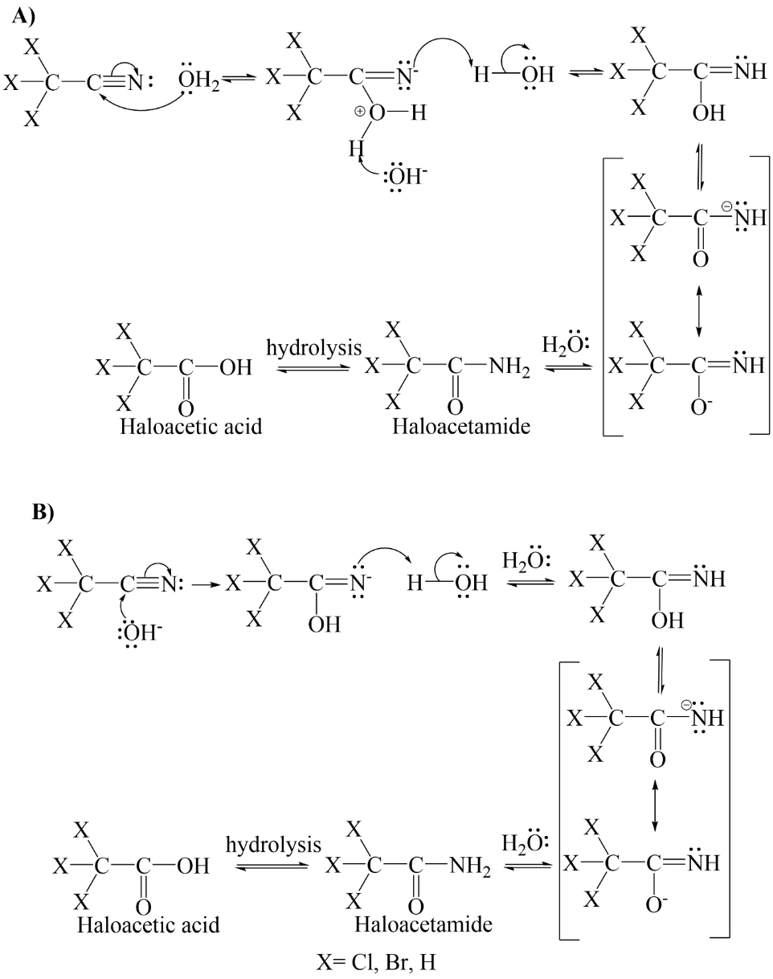
Figure 1. (A) Neutral and (B) base hydrolysis of haloacetonitriles. (A) Nucleophilic water adds to the nitrile carbon to produce imine as an intermediate that undergoes a series of proton shifts that results to a haloacetamide. Haloacetamide can further hydrolyze to produce haloacetic acid. (B) the hydroxide ion adds to carbon-nitrogen triple bond by nucleophilic substitution to form an imine which also undergoes a series of proton shifts to produce haloacetamide that hydrolyze to produce haloacetic acid. Adapted from (Jones, 2005).

Figure 2. SPME procedure conditions A) extraction time (desorption at 200⁰C for 3 mins) B) desorption temperature (30 min extraction and 3 min desorption time), and C) desorption time (30 min extraction time, 250⁰C)

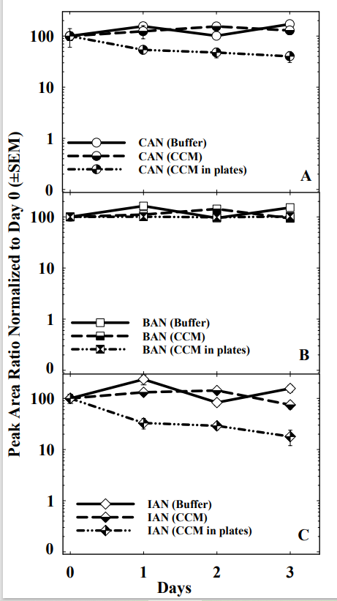
Figure 3. Stability of monohaloacetonitriles in buffer solution, cell culture media (CCM), and CCM in plates.

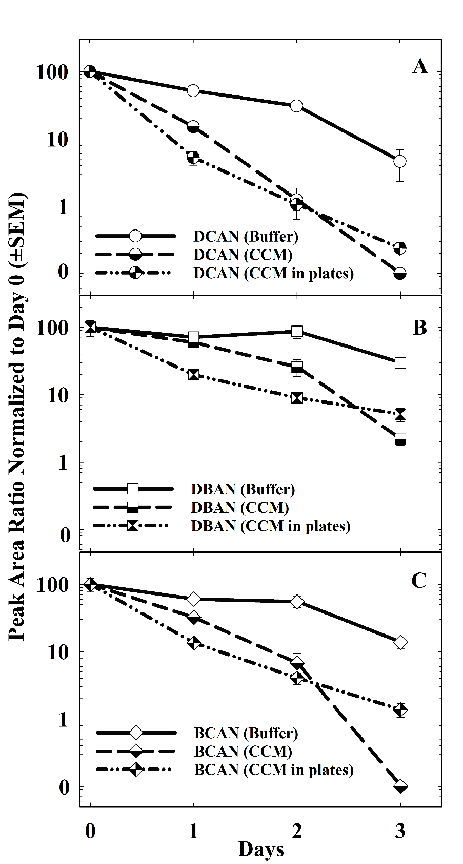
Figure 4. Stability of dihaloacetonitriles in buffer solution, cell culture media (CCM), and CCM in plates.
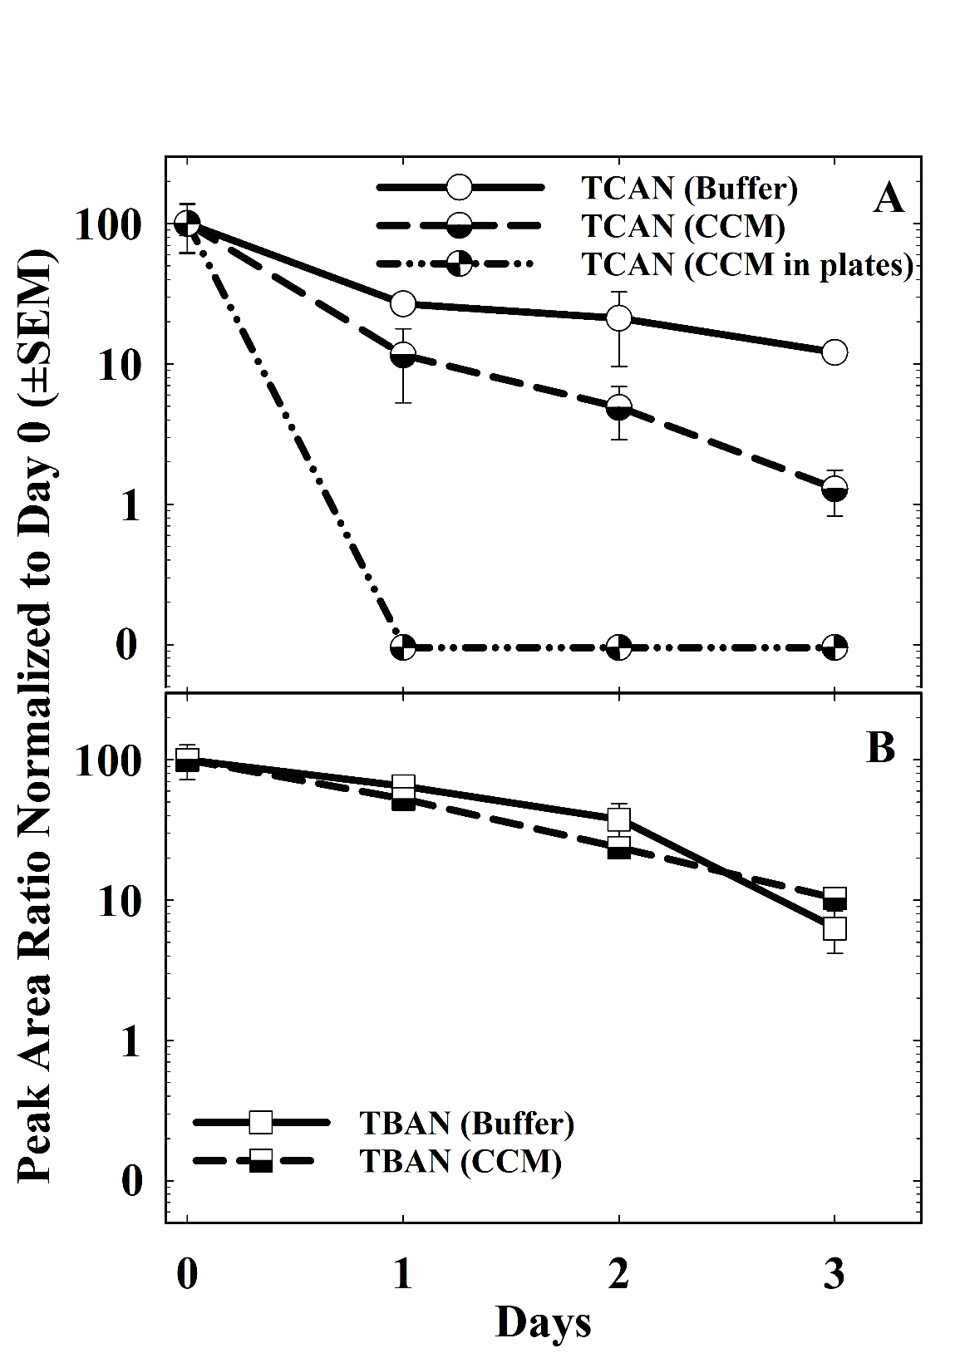

Figure 5. Stability of trihaloacetonitriles in buffer solution, cell culture media (CCM), and CCM in plates.
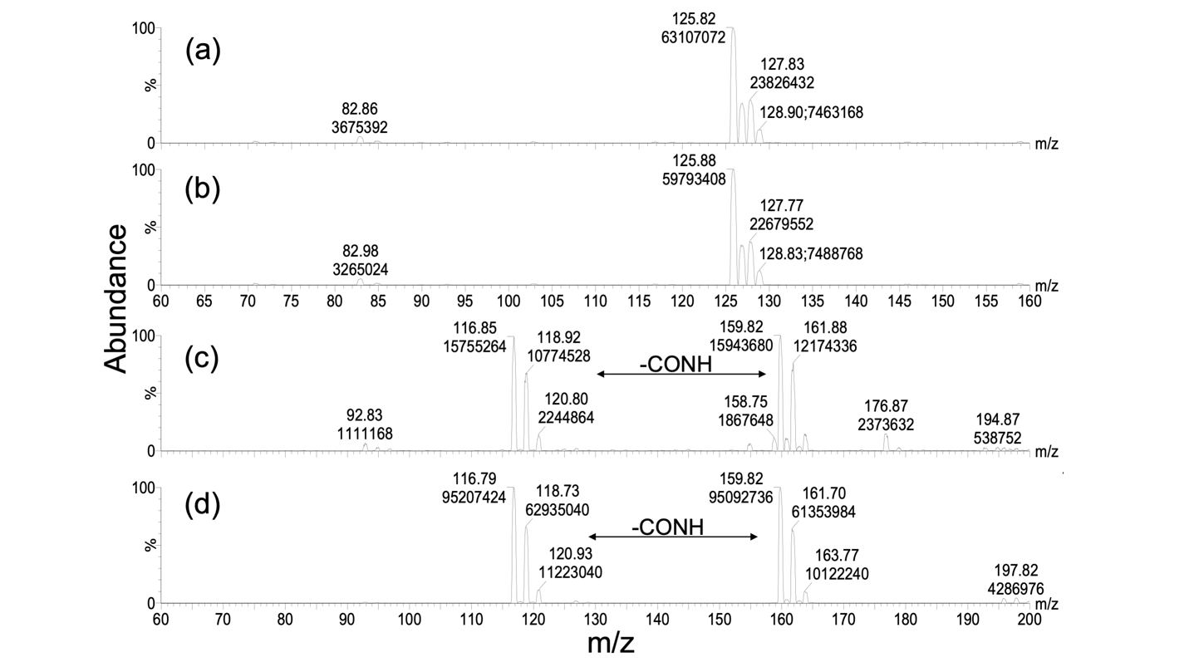Figure 6. Mass spectra of PIS m/z 35 of (a) incubated DCAN solution and (b) DCAM analytical standard (c) incubated TCAN solution, and (d) TCAM analytical standard

